Sandra Ann (Louque) Clement
August 9, 1946 - September 13, 2025

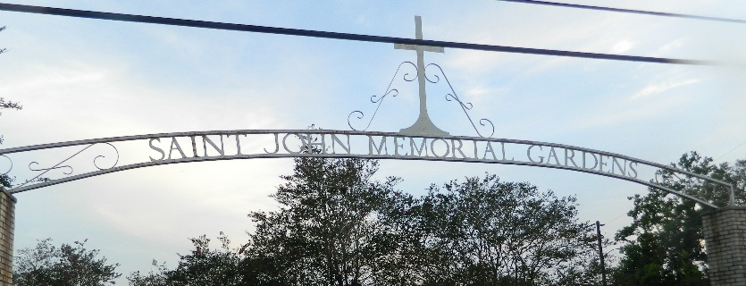

Sandra Ann Clement a native of Grand Point and a resident of LaPlace, LA unexpectedly passed away on Saturday, September 13, 2025 at the age of 79.
Beloved wife of the late Dale Clement, Sr. for 36 years. Loving mother of Tanya Gaspard (the late Patrick), Dale Clement, Jr. (Kristi), and Cassie Clement. Grandmother of Barrette Trosclair, Jr (Kristy), Austin Trosclair (Erika), Destiny Trosclair, Hunter Clement (Morgan), Amber Clement (Luke) Brandon Hotard, and Alicia Sagona. Great-grandmother of Karsyn, Nola, Callan, Barrette, III., Camryn, Kinleigh Trosclair, baby girl Trosclair on the way, Kailey Bourgeois, and Chance Oubre.
Daughter of the late Kearney Louque, Sr. and Jeanne Martin Louque. Sister of Yvonne Louque, Catherine Pelham, Richard Louque, Sr, Jeanne Bourgeois (Michael), Robert “Marty” Louque Sr, Wanda Gail LeBoeuf, the late Kearney Louque, Jr., Joyce Keating, and Betty McLeod. Also survived by numerous nieces, nephews, and cousins.
Sandra loved to travel, do crossword puzzles, play bingo, talk to everyone, tell her stories and most importantly her grandchildren and great-grandchildren.
Relatives and friends are invited to attend the Visitation and Funeral Mass on Saturday, September 27,2025 at St Joan of Arc Catholic Church. Visitation from 10:00 am- 12:00pm with the Funeral Mass to begin at 12:00pm. Burial will follow the service at St John Memorial Gardens.

Rose Lynn Funeral Home, Lutcher, Louisiana
September 26, 2025

