Bobby Joe Collins

December 17, 1938 – December 11, 2020

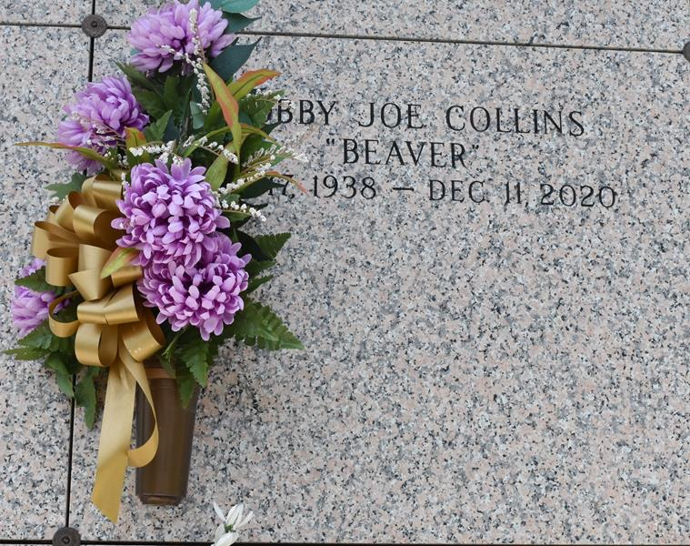

Bobby Joe "Beaver" Collins, age 81, of LaPlace, LA, went home to be with his Lord and Savior on Friday December 11, 2020. He was born on December 17, 1938 in New Orleans, LA.  
 He is survived by his children Pastor Carla Collins Ceaser Jones (Barry) and Amin Collins and was blessed with three grandchildren; Aurejana Anderson (Vernon), Kai Dubois (Chris) and Colin Ceaser (Danielle). He was also blessed with five great-grandchildren Christian, Kaila, and Cade Anderson, Carver Dubois, and Cailyn Ceaser. He is also survived by his siblings; Wilfred Mitchell (Janice), Raymond Mitchell (Dana), Linda Hansley (Leonard) and Geraldine Robinson. He was loved by many nieces, nephews, other relatives and friends. His special nephew Keiron Kelly and dear friends Mercedes Bourgeois, Donald Braud, and Gary Joseph.  
 He was preceded in death by his parents, Helen Kelly and Wilfred Mitchell, Sr.; brother, Junior Kelly; nephew, Keir Kelly; grandmother, Aurelia Mitchell Kelly Williams. Bobby Joe "Beaver" was a lifelong musician who traveled the world and performed with many notable entertainers of his era. He was loved by many and will be truly missed.  
 Family and friends are invited to attend the homegoing celebration on Friday, December 18 at 11 a.m. at New Wine Christian Fellowship, 1929 West Airline Highway LaPlace, LA. Visitation will be from 10 a.m. until service time. Interment will be at St. John Memorial Gardens. Viewing will also be held Thursday, December 17, 2020 from 4 p.m. to 6 p.m. at Bardell's Mortuary, 3856 LA-44, Mt. Airy, LA 70076.  
  
The Times-Picayune, New Orleans, Louisiana

Dec. 16 to Dec. 18, 2020