Elliott Joseph Cook

## January 14, 1938 – August 3, 2021

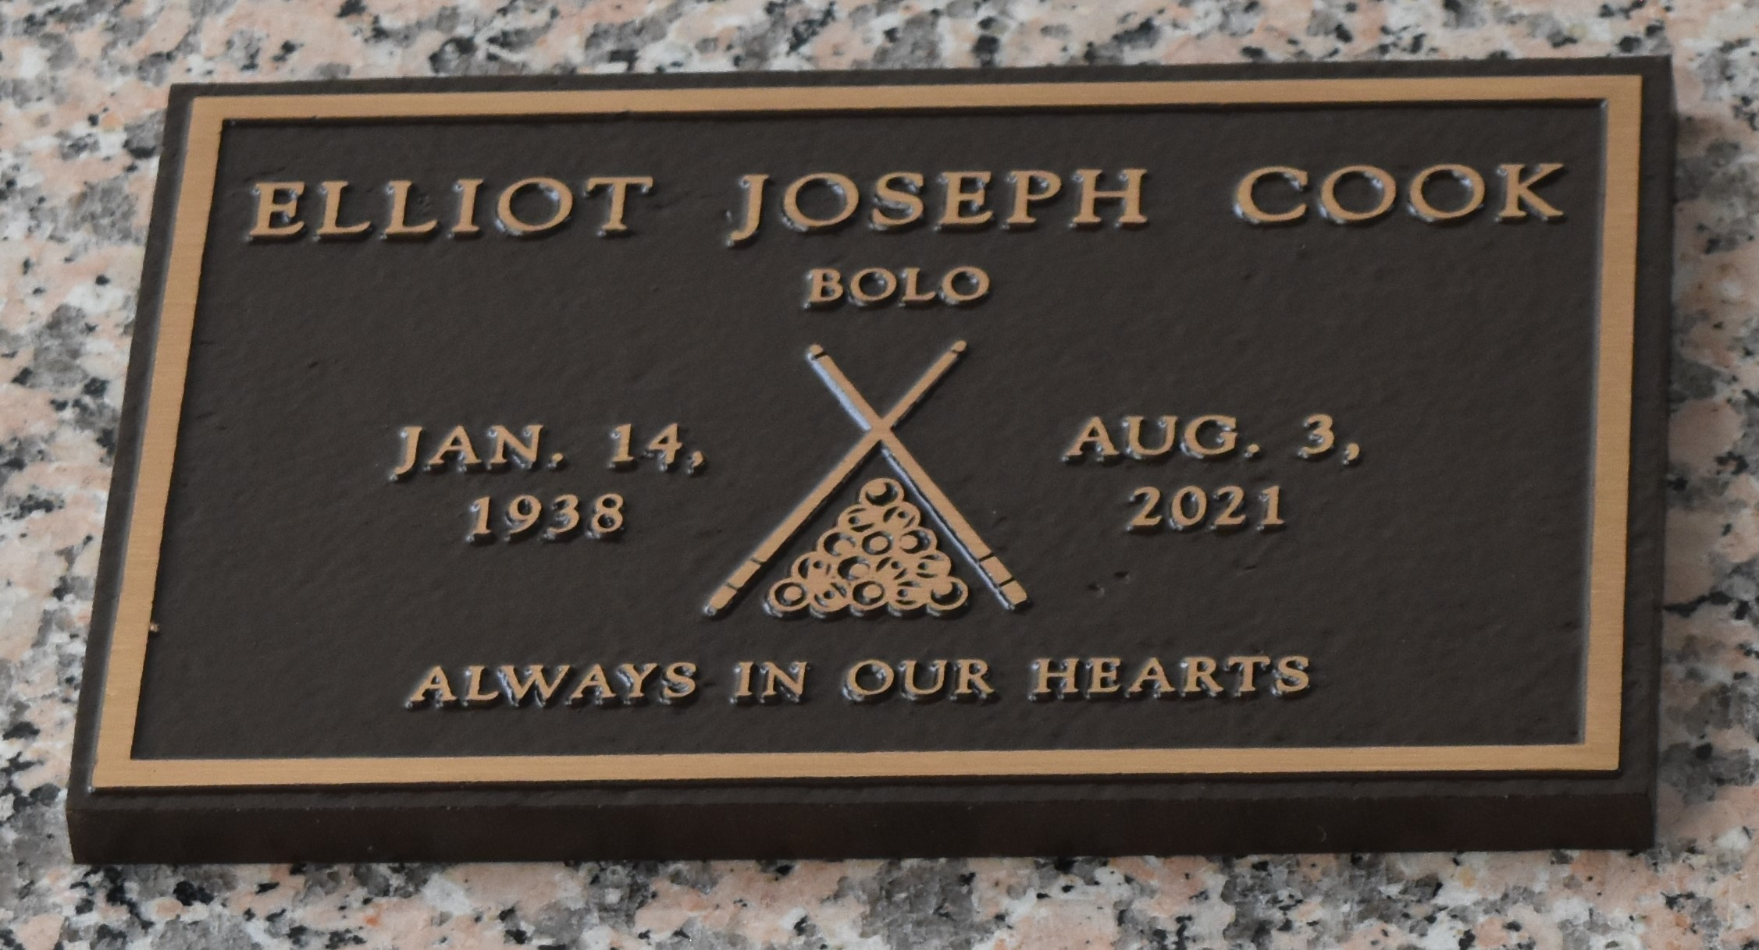

Elliott Joseph "Bolo" Cook at the age of 83 years departed this Earth life and entered eternal rest on August 3, 2021, at Twin Oaks Nursing Home in LaPlace, LA. Son of the late Edward Perrilloux and Elizabeth Cook. Beloved husband of Juanita B. Cook. Loving father of Desiree Jackson (Kelly), Troy Cook (Sheila), Murphy Cook, Ivy Smith (Corey), David Cook, and Elliott Darnell Cook. Also survived by 15 grandchildren, 15 great-grandchildren, nieces, nephews, other relatives, and friends. Elliott was preceded in death by his parents, Edward and Elizabeth Cook Perrilloux; his siblings, John, Richard Perrilloux, Edwin, Anderson Sr., Ferdinand Sr., Leatrice P. Young, Mavis P. Fobb, Donna P. Kendrick, Norman Weston, and Verna C. Cosey.

A private funeral service will be held Wednesday, August 11, 2021 at Bardell's Mortuary, 3856 Hwy 44, Mt. Airy, LA 70076. Family and friends are invited to the visitation on Tuesday, August 10, 2021 from 3 p.m. to 6 p.m. at Bardell's Mortuary. Masks and social distancing will be enforced. Services entrusted to Bardell's Mortuary. Information: (985) 535-6837.   
  
The Times-Picayune, New Orleans, Louisiana

August 9 to August 11, 2021