Emma Mae (Johnson) Cook

January 30, 1948 – December 24, 2010

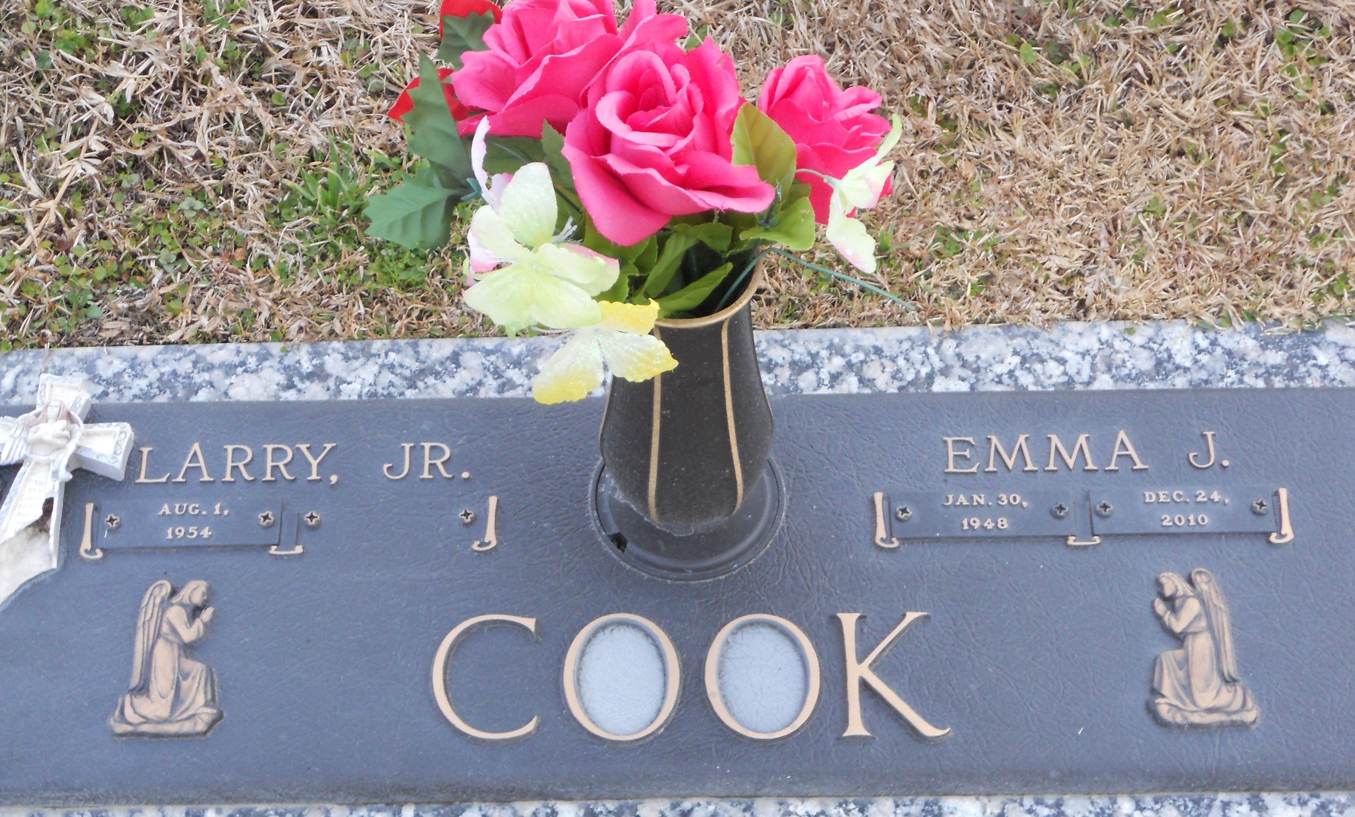

Photo by Team T-Lo

Emma Mae J. Cook on Friday, December 24, 2010 at River Parishes Hospital, LaPlace, LA. Daughter of the late Leona Booker and Oscar Johnson, Sr. Wife of Larry Joseph Cook, Jr. Mother of Zolton Johnson (Valerie) of Columbus, GA, David Parker, Jr., Chantrell Jimmerson (Lanson) both of Reserve, LA and Naydia Armstrong (Kalvin) of LaPlace, LA. Sister of Winnie Coleman, Odrie Nicholas (Roland) both of LaPlace, LA, Gladys Jackson of Reserve, LA, Dwayne Johnson of Jacksonville, FL, Adonis Johnson of Oakland, CA, Linda Johnson of LaPlace, LA, the late Inez Vampran and Oscar Johnson, Jr. Also survived by 10 grandchildren, 5 Godchildren and a host of nieces, nephews, other relatives and friends. Age 62 years. A native and resident of Reserve, LA.
Relatives and friends of the family, also pastors, officers and members of Greater New Plymouth Rock Baptist Church and all neighboring churches are invited to attend the funeral at Greater New Plymouth Rock Baptist Church, 110 Northwest 13th Street, Reserve, LA, on Wednesday, December 29, 2010 at 12:00 noon. Pastor David B. Carter, Officiating. Interment St. John Memorial Garden Cemetery, LaPlace, LA. Visitation at the above named church from 10:00 AM until Service time. SERVICED BY ROBOTTOM.
The Times-Picayune, New Orleans, Louisiana
December 28, 2010

