Larry Joseph Cook, Jr.

August 1, 1954 – February 4, 2022

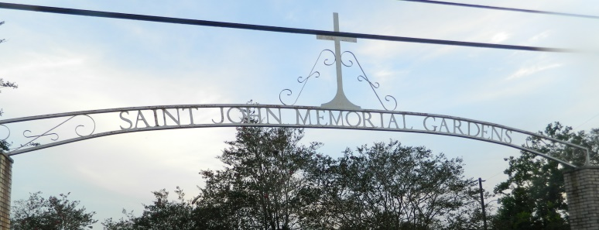

Larry Joseph Cook, Jr. entered eternal life on Friday, February 4, 2022, at Ochsner Medical Center in Jefferson, LA at the age of 67. He was born on August 1, 1954, in New Orleans, LA to the late Theresa Desselle Cook and Larry Cook Sr. He was a native and resident of Reserve, LA.  
 Larry was the beloved husband of the late Emma Johnson Cook.  
 Left to cherish his wonderful memories are his children, Zolton (Valerie) Johnson of Vacherie, LA, David Parker, of Garyville, LA, Chantrell (Lanson) Jimmerson of Reserve, LA, Naydia Cook of Laplace, LA, and Chesney Cook of Reserve, LA; siblings, Janice and Karen Cook both of Reserve, LA, Julie (Clarence) Variste, Connie (Nelson) Ramos, and Durel (Judy) Cook all of Laplace, LA, Kevin (Beatrice) Cook of Cerritos, California, and Darryl Cook; 10 grandchildren, 13 great-grandchildren, 5 Godchildren, and a host of nieces, nephews, other relatives and friends.  
 Relatives and friends of the family, also Pastors, officers and members of the Greater New Plymouth Rock Baptist Church, and all neighboring churches are invited to attend the funeral services on Saturday, February 12, 2022, at New Wine Christian Fellowship, 1929 W. Airline Hwy, Laplace, LA 70068 at 11am. Visitation period will be held from 9am until start of service. Pastor David B. Carter officiating. Interment to follow at St. John Memorial Gardens, 2205 W Airline Hwy, Laplace, LA 70068. Final care and professional services entrusted to Treasures of Life Funeral Services, 315 E Airline Hwy, Gramercy, LA 70052.

Treasure of Life Center, Gramercy, LA

February 25, 2022