Oscar Joseph Cook Jr.

## August 14, 1940 – April 23, 2016

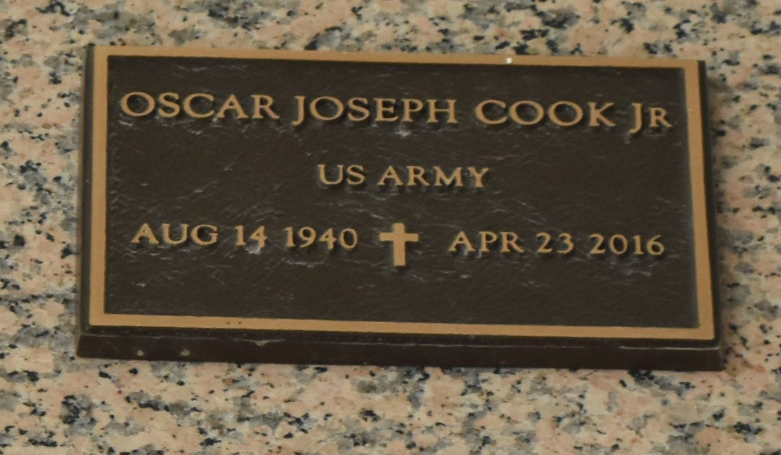

Oscar A. Cook, Jr. on Saturday, April 23, 2016 at his home in Reserve, LA Son of the late Alma and Oscar A. Cook, Sr. Husband of Doris Lewis Cook Father of Terren Cook, Oscar Cook, III (Tracy), Dynell Cook and Danielle Cook Singleton (Myron). Brother of Marie Stevenson, Goldie Wilkens (Clarence), Veronica Bailey (Herman), Elmo Cook (Elsie), the late Alvin, Lorenzo, Arthur and Henry Cook. Also survived by 8 grandchildren, 3 great grandchildren and a host of nieces, nephews, cousins, other relatives and friends. Age 75 years. A native and resident of Reserve, LA,

Relatives and friends of the family are invited to attend a visitation with the family at Robottom Mortuary, 850 Hwy 44 (River Road), Reserve, LA on Friday, April 29, 2016 from 4:00 PM to 7:00 PM Burial will be private SERVICED BY ROBOTTOM.   
  
The Times-Picayune, New Orleans, Louisiana

April 26 to April 27, 2016