Crystal Gayle Cooke

## October 31, 1984 – November 20, 2001

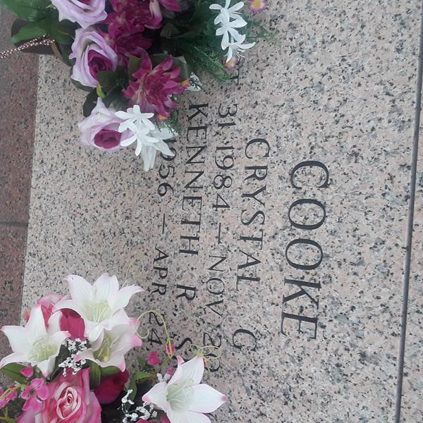

Crystal Gayle Cooke, 17, a native of New Orleans and resident of LaPlace, died Nov. 20. She was the daughter of Kenneth Sr. and Juanita Ponthieux Cooke and Kelly Wolfe and sister of Lisa, Nora, Corena and Kenneth Cooke Jr. She was the granddaughter of Evie Lee Cooke of LaPlace and the late Charles Cooke Sr. and Mr. and Mrs. Fritz Ponthieux.

Services were Nov. 27 in the chapel of H.C. Alexander Funeral Home, Norco, with interment at St. John Memorial Gardens, LaPlace.

L'Observateur, LaPlace, Louisiana

November 28, 2001