Lawrence Cooper

## August 15, 1947 – March 13, 2000

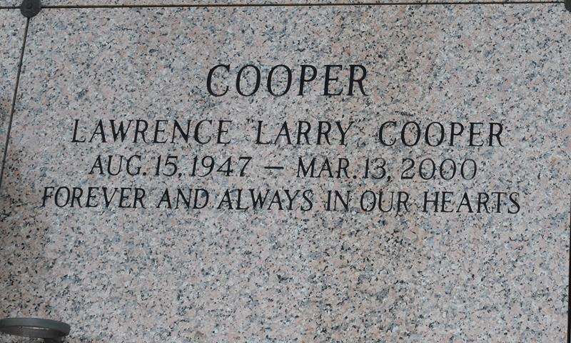

LAPLACE - Lawrence "Larry" Cooper, 52, a native of Gramercy and resident of LaPlace for the past 15 years, died March 13. He was the husband of Jenny Lirette Cooper and the father of Daron and Dominic Cooper, Raynell Turner and the late Lawrence Jackson. He was also the son of Eula Myles Cooper and the late Lloyd Cooper. He is also survived by four grandchildren.

Services are today at 11 a.m. at Bethlehem Missionary Baptist Church, Reserve, with interment at St. John Memorial Gardens Mausoleum, LaPlace. Visitation begins at 9 a.m.

L'Observateur, LaPlace, Louisiana

March 19, 2000