Jacquel M. Cosey
April 15, 1994 – October 23, 2020
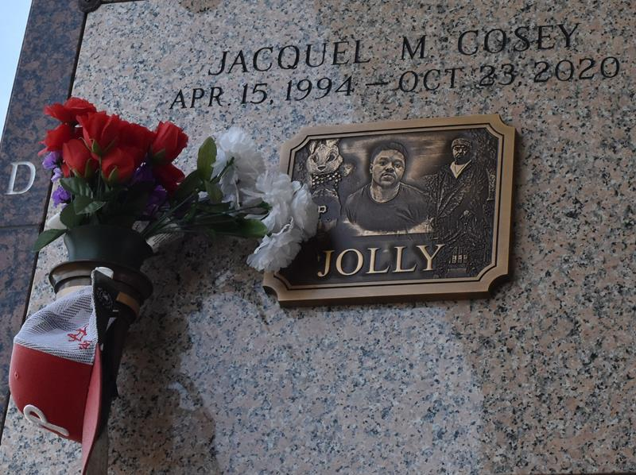

Jacquel (Jolly) Cosey, age 26, passed away on Friday, October 23, 2020. Son of Vanessa Cosey and Leroy Jackson, Sr., he was reared by Ricky Labranch. Brother of Lanisha and Nijeion Cosey, Leronca Beasley, Leroy Jackson, Jr., Donte and Daquan Doss, Tristan Lee, K'Ron Mealey, uncle of Harleigh and Hayden Decay and Natalya Beasley, grandson of Douglas Cosey, Sr., and the late Willa Mae Jarrow Cosey, Ernest and Mary Jackson, Jacquel is also survived a stepson, Carter Nelson, a host of aunts, uncles other relatives and friends.
Funeral Service on Saturday, October 24, 2020 at Greater Golden Grove B.C., 127 S. Mulberry St., Gramercy, La. at 11:00 am., Rev. Ulysses Jarrow Officiating. Interment in St. John Memorial Laplace, La. Visitation at 10 am until service time. Due to CDC (Covid 19) restricting seating is limited. Masks and social distancing are required. Professional services entrusted to the caring staff of Hobson Brown Funeral Home, 134 Daisy St., Garyville, La. 70051, 985-535-2516.
The Times-Picayune (New Orleans, LA)
Nov. 5 to Nov. 6, 2020

