Michael Anthony Creecy

June 19, 1956 – May 28, 2014

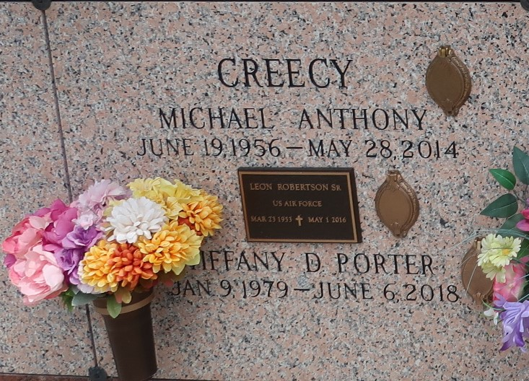

Michael Anthony Creecy, 57, entered in eternal rest on Wednesday, May 28, 2014. Son of the late Louise Jones and Eddie Creecy, Sr. He leaves a legacy of love with his beloved wife Beverly Robertson Creecy, daughters Marquesha Creecy and Tiffany D. Porter, one grandson I'yan Reynaud, brothers, sisters and a host of nieces, nephews, other relatives and friends.

Funeral Services will be on Saturday, June 7, 2014 at 1:00pm at Pilgrim B.C. 107 Pilgrim Dr. Reserve, LA, Rev. Forell Berring, Sr. pastor. Viewing 11a.m. until service time. Interment in St. John Memorial, Laplace, La. Employees of DaVita Dialysis Center, Ochsner Kenner and Ochsner Jefferson, St. John Parish school system, Kaiser Aluminum, Cargill grain elevator, and Care INC are invited to attend. Services Entrusted to Hobson Brown Funeral Home, 134 Daisy St., Garyville, La 70051 985-535-2516.

The Times-Picayune, New Orleans, Louisiana

June 5 to June 6, 2020