Patrick Lee Cupit

July 11, 1995 – March 31, 2013

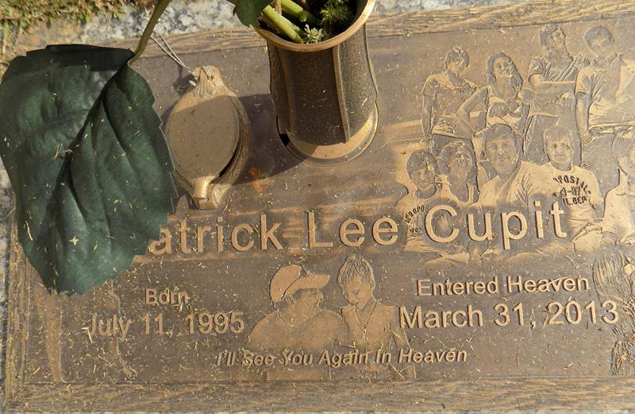

Patrick Lee Cupit entered this world on July 11, 1995, was baptized on September 23, 1995, and entered heaven on Easter Sunday, March 31, 2013. Patrick lived in LaPlace, LA, graduated Valedictorian from St. Joan of Arc Catholic School, had attended Jesuit High School in New Orleans, and was accepted to the University of Louisiana, Lafayette, for the fall 2013 semester.

Patrick will be loved and missed by his parents, Don and Suzanne Cupit, sister Katrina Cupit, brothers Johnny, Joshua, Garrett, Emile, and Jeffrey; grandparents Peggy and Stephen Cupit and Faye and Ed Dewey; aunts and uncles Sheri and Anil Raj, Godparents Jeannie and Ricky Tiemann, Julie and Stephen Cupit, Stephanie and Thomas Brothers, Shannon and Marcel Jaubert; cousins Chelsie and Stephen Cupit, Carmen, Thomas and Jack Brothers, Emily, Adrienne, Erin, Lauren and Daniel Jaubert, Jake Canzoneri and Michael Zdenek, Camille and Alex Tiemann; his closest friends Mark Jacob, Royce Zeringue, Ryan Firmin, Nash Babin and cousin Stephen Cupit, and the joy of his days, girlfriend Stephanie Korle; and anyone who had the privilege of experiencing the humor and wise insight of "Patty Wack". To all those who offered support and prayers for Patrick's healing, the family wishes to extend heartfelt appreciation and we pray that you, too, recognize in your sorrow for the loss of Patrick on this earth, that Patrick is walking, pain free, with our Lord in heaven and all the angels and saints including his uncle Jeff, grandfather Richard, siblings Karen and James, and all the relatives and friends who welcomed him into heaven. We will see him again.

All friends are invited to honor Patrick at St. Joan of Arc Catholic Church, 529 W. 5th Street, LaPlace, LA beginning with a wake on Wednesday, April 3, from 6pm - 9pm, and visitation on Thursday, April 4, from 9:30am-11am, Mass will begin at 11am. Patrick will be laid to rest at St. John Memorial Gardens in LaPlace. SERVICE BY ROBOTTOM.

The Times-Picayune, New Orleans, Louisiana

Wednesday, April 3, 2013

Contributed by Jane Edson