Nolan L. Darby, Sr.

September 23, 1940 – June 7, 2017

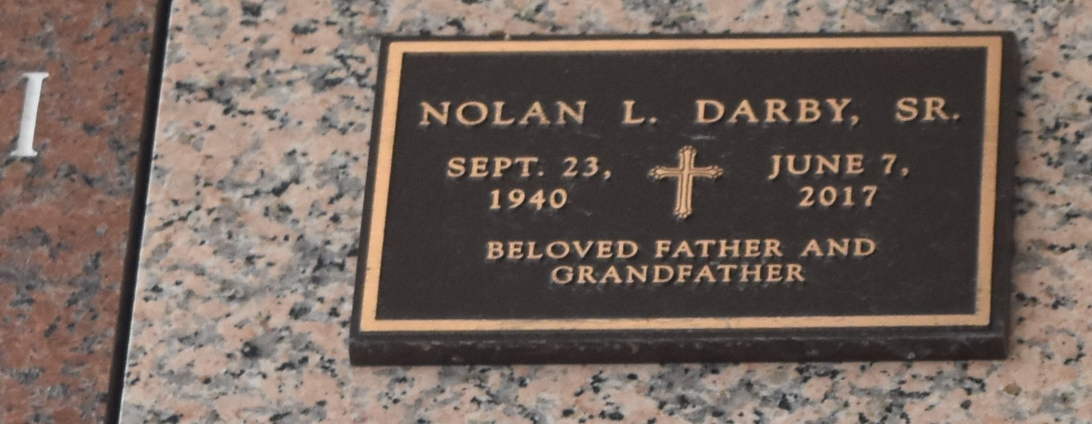

Nolan L. Darby Sr, 76, of Kenner, LA, passed away on June 7, 2017 at his home. He was born to the late Sidney and Viola Darby in Abbeville, LA. Loving father of Nolan L. Darby Jr, Nadia S. Dixon, and Derek Darby. Grandfather of Devin Rayfield and Zion Darby. Brother of Robert and Flora Darby. He was a retired employee of Budget Rental Car in Kenner, LA.

Relatives, friends and pastors, officers, and members of neighboring churches are invited to attend a one hour memorial service at 12pm on Friday, June 16, 2017 at Our Lady of Perpetual Help Catholic Church on 1908 Short Street Kenner, LA 70062. Private burial.

The Times-Picayune, New Orleans, Louisiana

Jun. 13 to Jun. 14, 2017