Donna Davidson

December 7, 1947 – March 27, 2010

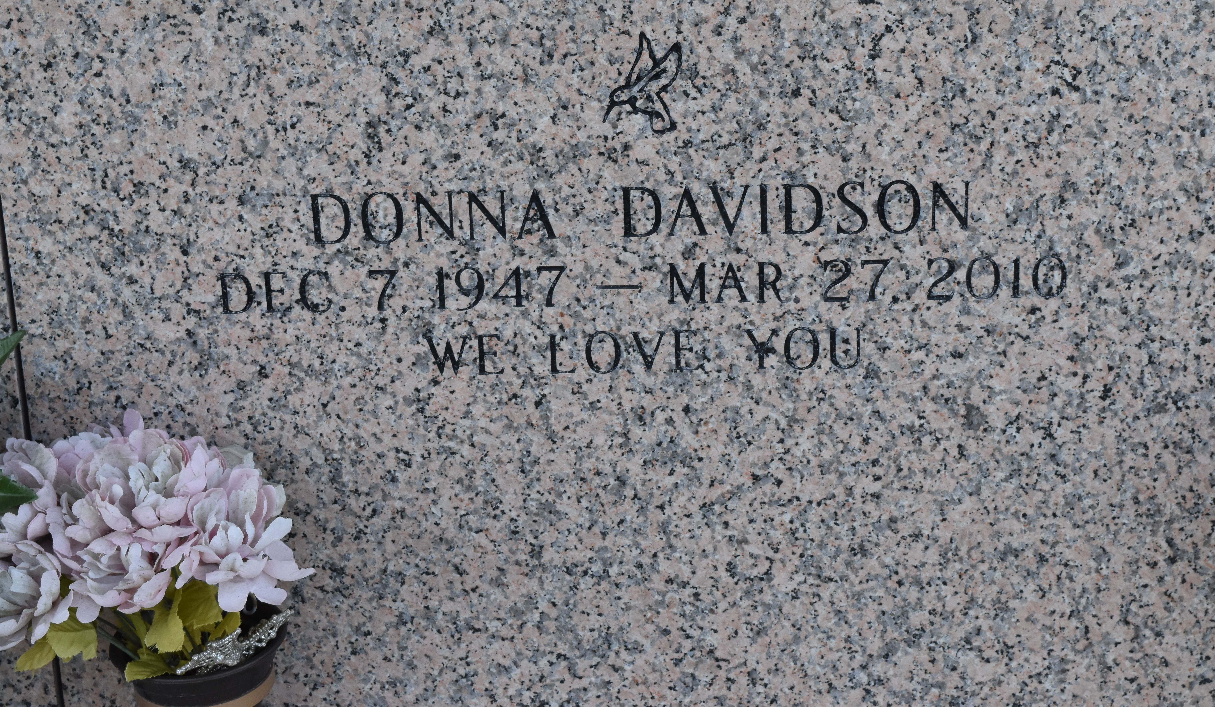

Donna Davidson of LaPlace, LA passed away, surrounded by her family, on March 27, 2010 at 8:20 p.m. following a courageous battle with cancer. Donna was the beloved wife of Herschel Davidson, beloved mother of the late Barbara Davidson Caillouette, beloved grandmother "NaNa" to Brandon Davidson and Cody Caillouette, beloved sister of Pat Kuhn and Debra Harris, beloved friend to many. Donna was a professional waitress who worked at Middendorf's, Chinese King, Donut Hole, and Randa Corporation. Funeral

Services will be held on Tuesday, March 30, 2010 at Millet-Guidry Funeral Home from 5:00-6:00 pm at 2806 West Airline Hwy., LaPlace, LA, 985 536 7700. Everyone is welcome. Special thanks to Compassus and River Region Hospices for their compassionate service.

The Times-Picayune, New Orleans, Louisiana

Mar. 30, 2010