Avery Raymond Davis

February 23, 1986 – October 29, 2014

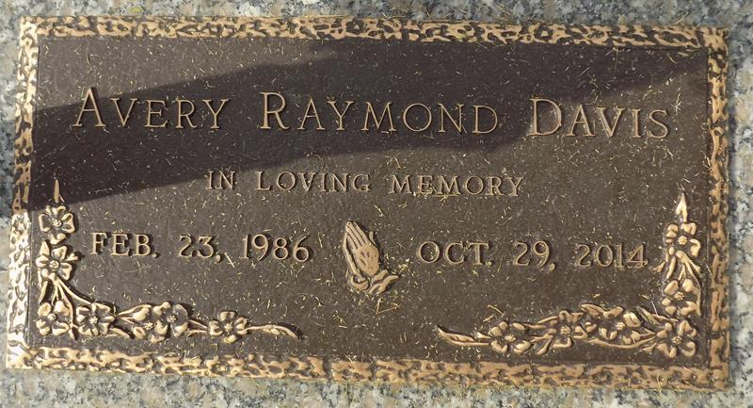

Avery Davis passed away on Wednesday, October 29, 2014 at Ochsner Medical Center Kenner, Kenner, LA. Son of Janice Roberts Thompson and Raymond Davis. Stepson of Michael Thompson. Brother of Gerard Simms (Venus), Kerwin Davis (Brianna), Torrey LaFrance Vedor (Damascus, Sr.), Toneka Ellis (Timothy), Toney Davis (Porcha), Toneil Pinkney, Michael Thompson, Jr. and Jalessa Campbell. Also survived by a host of aunts, uncles, nieces, nephews, cousins, other relatives and friends. Age 28 years. A native of Plaquemine Parish and a resident of LaPlace, LA.

Relatives and friends of the family, also pastors, officers and members of Celebration Church and all neighboring churches are invited to attend the funeral service at Celebration Church, 3400 Highway 51, LaPlace, LA on Saturday, November 8, 2014 at 12 noon. Pastor Checkerz Williams, Officiating. Interment St. John Memorial Garden Cemetery, LaPlace, LA. Visitation at the above named church from 10:00 AM until service.

Unknown source