Helen Rose Pierce (Landry) Davis

June 5, 1922 – October 4, 2019

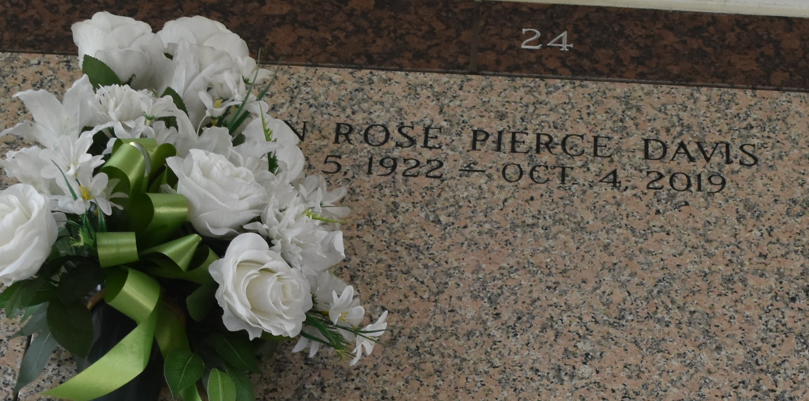

Helen Pierce Davis, born June 5, 1922 in Kaplan, Louisiana, passed away at the age of 97 on October 4, 2019 in LaPlace, Louisiana. She is survived by her son, Michael L. Pierce (Cecilia), and daughter Marguerite P. Fleming (John). She is also survived by her grandchildren, Scott Pierce (Jennifer), Eugene Edwards Jr., John Michael Edwards, Deanna Schexnayder (Lorne), Chris Fleming (Fiancé Megan), and Brenda Simoneaux (Arthur), as well as her three great grandchildren, Candace Caminita, Kynlee Fleming, and McKenzie Pierce, and a host of nieces, nephews, and family members to cherish her memory.

She is preceded in death by her grandson, Matthew Pierce, brother Robert Landry, sister Eula Landry Guillotte, and her parents, Leonard and Camilla Marceaux Landry. Relatives and friends are invited to attend a visitation at H.C. Alexander Funeral Home, 821 Fourth St. Norco, LA, on Tuesday, October 8, 2019 beginning at 10:30 AM. Funeral services will take place at 12PM with burial to follow at St. John Memorial Garden in Laplace. To share a memory with the family please visit [www.HCAlexander.com](http://www.HCAlexander.com/)[.](http://www.hcalexander.com./)

Dignitymemorial.com from HC Alexander Funeral Home