Robert Calveal Davis Jr.

May 14, 1961 – September 26, 2021

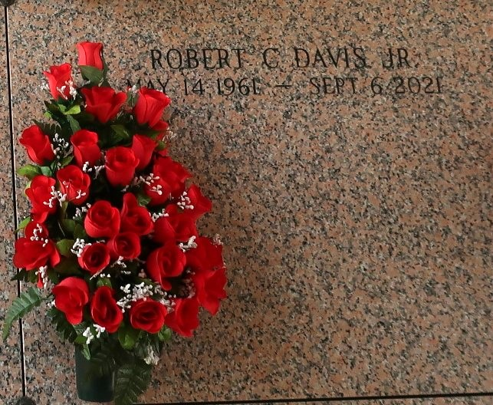

Robert C. Davis, Jr., age 60, and a resident of LaPlace, LA departed this life on September 6, 2021, at Ochsner Hospital in New Orleans, LA. Despite having no symptoms of illness, he collapsed on Saturday, September 4, 2021. He was taken by EMS to Ochsner Medical Complex - River Parishes then airlifted to Ochsner's Main Campus. His attending physicians concluded that he did not have COVID.

Robert accepted Christ at an early age and was baptized by Rev. Jesse Clay at Antioch Baptist Church, a Louisiana historical landmark. He was the youngest person to ever serve as a deacon at Antioch Baptist Church. He later served as an usher at Israelite Baptist Church in Lutcher, LA. Robert is a graduate of Lutcher High School and Central Texas College. He joined the Louisiana National Guard in 1979 and later received Combat Engineer and Civil Disturbance Training certifications. In 1985, he joined the U.S. Army. He later received his Aircraft Fire Control System Repair and Cobra Helicopter, Weapon and Electrical Repair certifications at Hunter Army Airfield. While in the Army, Robert traveled to and lived in several foreign countries including South Korea. After an honorable discharge from the military, Robert became an employee of Schneider National with a specialty in transporting caustics. He later became an owner operator and certified trainer with Schneider. After leaving Schneider, he became an employee at Quality Carriers and remained with this company until his death.

Although Robert's death was unexpected, he lived his life in a very deliberate manner. Daily, it was his goal to brighten someone's day. He was always upbeat and respectful to others. He greeted family, friends, neighbors, and strangers with a smile. He "checked" on loved ones and friends with a daily phone call. Everyone will miss his sense of humor. Robert became an avid reader at a very early age with his extensive collection of comic books and interest in Greek mythology and the works of Shakespeare. He later became interested in the works of James Patterson and other mystery writers and shared his interest and books with others. He also enjoyed discussing and analyzing social injustices and domestic and international politics. Despite his love of politics, he spent considerable time before his death trying to convince others to relinquish their political viewpoints and to get COVID vaccines and wear masks.

Robert leaves the following persons to cherish his memory: wife of 30 years, Suk Hui; dad, Rev. Robert Davis, Sr.; siblings: Oletha, Lester, and Adrian; nephews: Kyron, Arinton, and Prince; Godchildren: Teran (Mourice) Ellis-Henry and Dyhn McKinley; Godparents: Catherine Jackson and Roosevelt Batiste; sisters-in-law: Chanda (Adrian), Yun Hui Hwang, Soong Yong Hui Hwang, and Kyung Hui Hwang; brother-in-law, Jung Hui Hwang; and a host of aunts, uncles, cousins, and friends. Robert was preceded in death by his mother, Traviter J. Davis, maternal grandmother, Maude Barney, and paternal grandparents Evelina and Rev. Andrew Jackson, Sr.

A public walk-through visitation will be held on Sunday, September 12, 2021 from 3pm - 4pm at Treasures of Life Funeral Services, 315 E. Airline Hwy., Gramercy, LA 70052. A private memorial with family members will be held on Monday, September 13, 2021, at Treasures of Life Funeral Services. Visitation begins at 10am until services at 11am. Pastor Adraine Jackson White of Abounding Love Ministries, 7076 Hooper Road, Baton Rouge, LA 70811 officiating. Entombment to follow at St. John Memorial Gardens in LaPlace, LA. Final care and professional services entrusted to Treasures of Life Funeral Services.

Treasures of Life Funeral Services, Gramercy, Louisiana