Sherman Alfred Davis

1943 – August 4, 2018

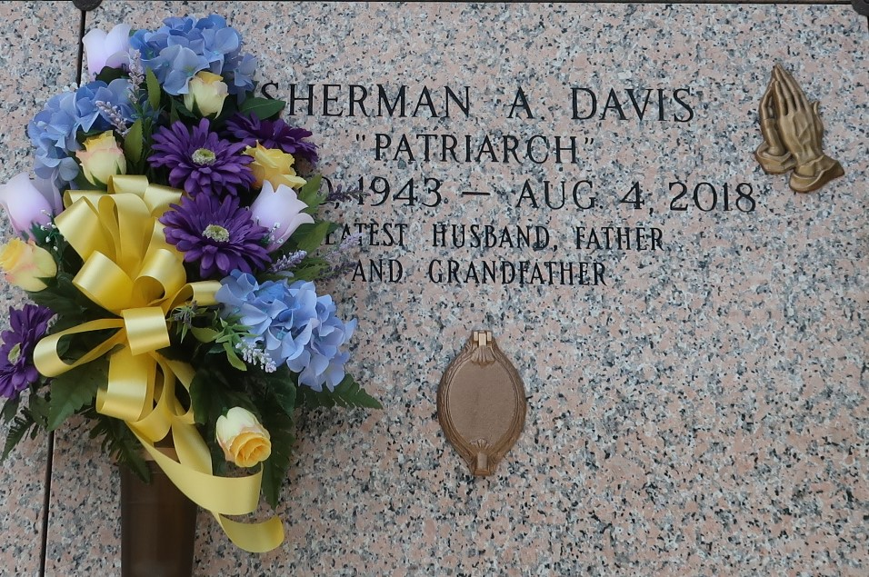

Alfred "Sherman" Davis, at the age of 75 yrs, departed this earthly life and entered into eternal rest on Saturday, August 4, 2018 at East Jefferson Hospital of Metairie, LA.  
 Beloved husband of Vivian Davis of LaPlace, LA. Loving father of Wendolyn (Margo) Davis, Penny (Juan) Watkins Sr., Desmond and Trent Davis, all of LaPlace, LA. Beloved Brother of Delores Richard, Marion Francis, Richard Davis Jr., and Orelia Torrence. Also survived by 8 grandchildren, 2 great-grandchildren, nieces, nephews, other relatives, and friends. A native of Montz, LA and a resident of LaPlace, LA.  
 Sherman was preceded in death by his parents Orelia and Richard Davis Sr., siblings Leroy Mason Sr., Doris Anderson, Verla Mae Noble, Joe Washington, and Philonese Brumfield.  
 Pastors, officers, and members of the Powerhouse Christian Church of LaPlace, LA, Employees of CarQuest, Advanced Auto Parts, and all neighboring churches are invited to attend the Homegoing celebration on Saturday, August 11, 2018 at 11:00 a.m. at the Powerhouse Christian Church 366 Redwood St. LaPlace, LA. Pastor Randolph Anthony officiating. Interment in St. John Memorial Gardens of LaPlace, LA. Visitation will be at the above named church from 9:00 a.m. until service time.  
  
The New Orleans Advocate, Louisiana

Aug. 8 to Aug. 11, 2018