Elaine (Lasseigne) de Bautte

December 24, 1939 – February 6, 2016

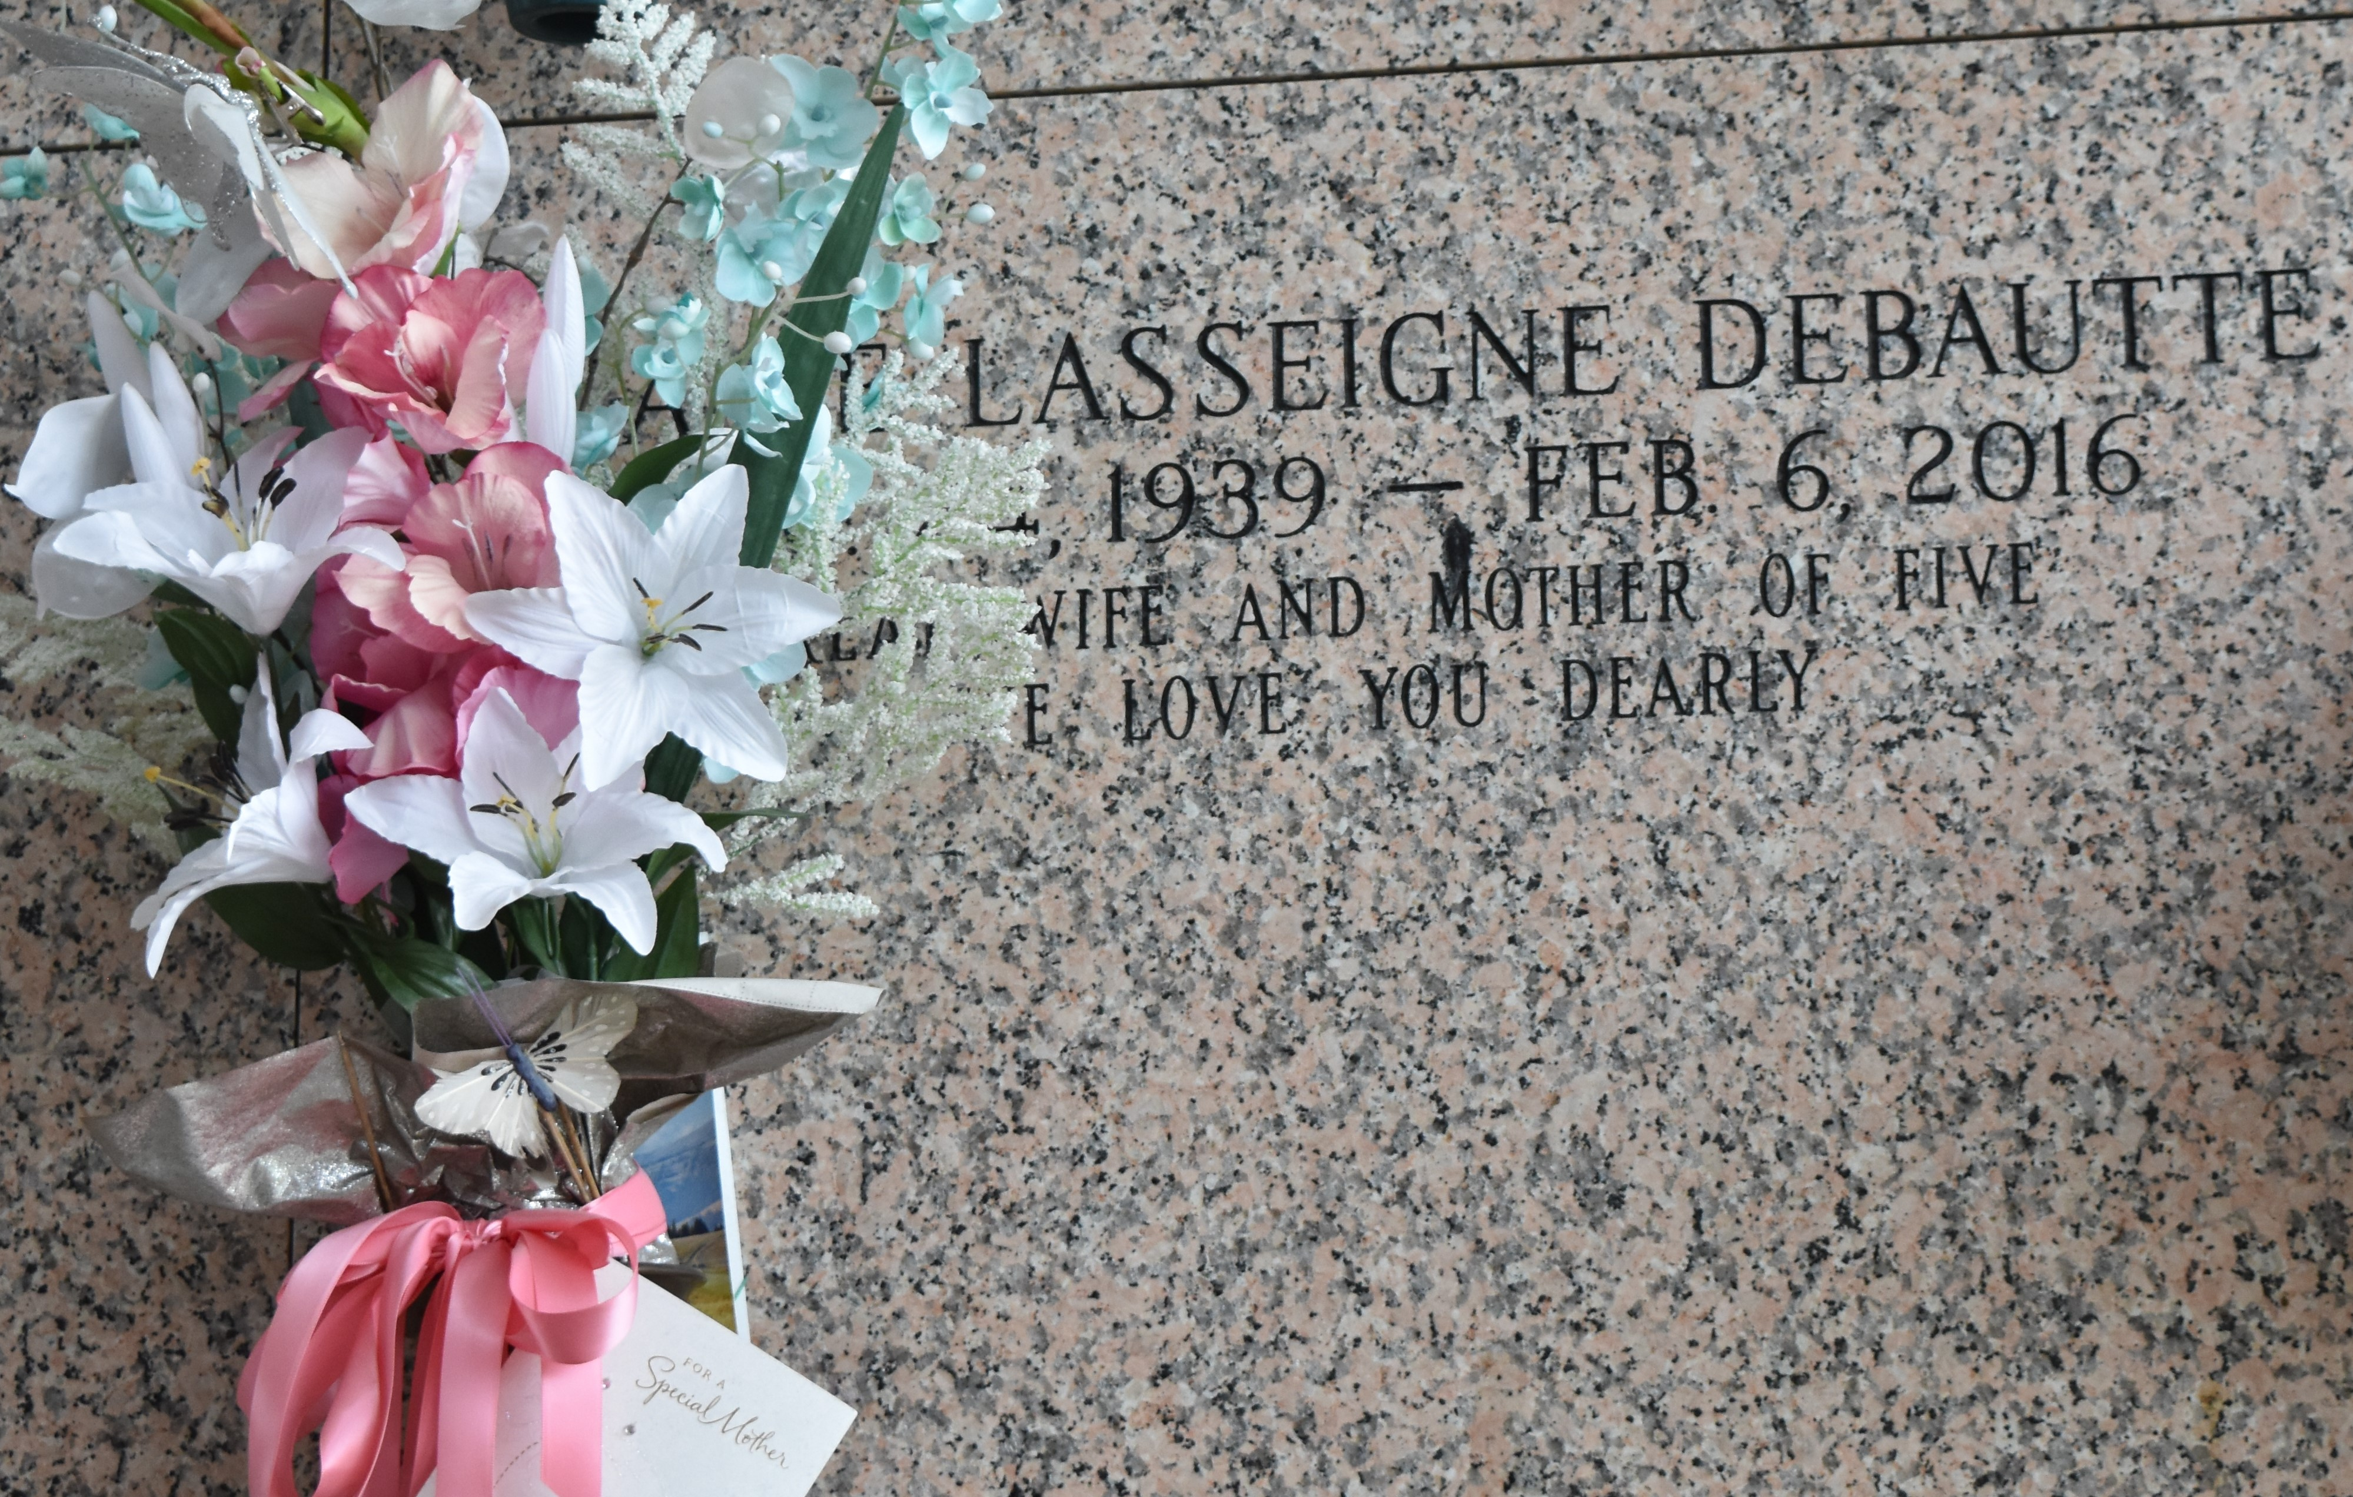

Beloved wife and mother, entered into eternity on Saturday, the 6th day of February, 2016, at 12:42 p.m. Elaine was the beloved wife and lifelong partner of Warren "Mousey" Philip DeBautte for nearly 58 years. She was the loving mother of two sons and three daughters, the late Steven Paul DeBautte, Tammie DeBautte Clement, Cindy DeBautte Darden (Mike), Cheryl DeBautte Quamme (Douglas), and Warren "Bubba" Philip DeBautte, Jr. (Robin). She is survived by one sister, Roline "Cookie" Lasseigne Alexander, and one brother, Philip Lasseigne, nine grandchildren and twelve great grandchildren.

Elaine was preceded in death by one sister, Lorraine Lasseigne Boudreaux, and two brothers, Wayne "Whitey" Lasseigne and Robert Lasseigne, Jr. She was the daughter of the late Robert Lasseigne and Helen Millet Lasseigne. Age 76, a native of Reserve and resident of LaPlace for the last 65 years.

Relatives and friends are invited to attend the Funeral Service. Visitation will be held at Millet-Guidry Funeral Home, 2806 W. Airline Hwy., LaPlace, on Thursday, February 11, 2016, from 9:00 a.m. to 11:00 a.m., followed by the Funeral Mass in the funeral home Chapel at 11:00 a.m. Burial in St. John Memorial Gardens, LaPlace. To view or sign the online guest book, please visit [www.milletguidry.com](http://www.milletguidry.com/).

Legacy.com