Warren Philip de Bautte

May 26, 1936 – January 28, 2021

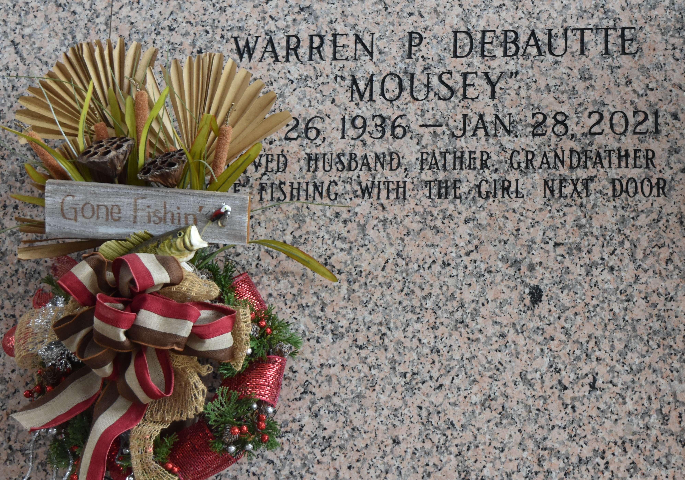

Warren "Mousey" Philip DeBautte entered into eternity on Thursday, January 28, 2021. He was 84 years old, a native of New Sarpy and a resident of LaPlace for 62 years. Mousey was the loving husband and lifetime partner of the late Elaine Lasseigne DeBautte. Loving father of 5 children, Tammie DeBautte Clement (Bobby), Cindy DeBautte Darden (Mike, deceased), Cheryl DeBautte Quamme (Doug), Warren "Bubba" Philip DeBautte (Robin) and the late Steven Paul DeBautte. He is survived by 9 grandchildren, 19 great grandchildren and 1 great-great grandchild. Son of the late Edgar Paul DeBautte and Annabelle Landeche DeBautte. Brother of the late Delores DeBautte Boudreaux. Also survived by nieces and nephews.

Mousey will join his wife, son, sister and parents, along with many other extended family and friends that have gone before him where he can continue fishing, shrimping, hunting, and crabbing on the shores of Heaven for eternity. He will be sadly missed by all.

Relatives and friends are invited to attend the Visitation and Funeral Service at Millet-Guidry Funeral Home, 2826 W. Airline Hwy., LaPlace, LA on Friday, February 5, 2021 from 9:30 a.m. to 11:30 a.m. with the Funeral Service to immediately follow at 11:30 a.m. Interment in St. John Memorial Gardens Cemetery.

Millet-Guidry Funeral Home, LaPlace, Louisiana

January 30, 2021