Mildred (Howard) Dennis

September 3, 1935 – September 6, 2008

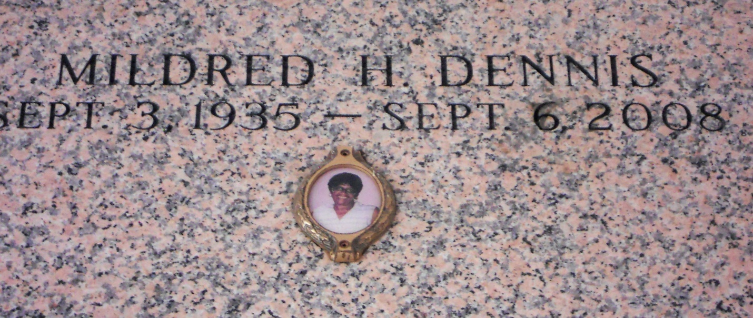

Photo by Team T Lo

Mildred (Tit, Toe-Toe) Dennis, age 73, a resident of Reserve, died on Saturday, September 6, 2008 at East Jefferson General Hospital in Metairie La. Daughter of the Late Gustave and Laura Howard. Wife of James Dennis Jr. Father of Joann Palmer, Yolanda Jones, James III, Andrew, Albertine, Joseph, Kevin, Lionel, Clifton, Gwendolyn, Randolph and Cheryl Dennis, and the late Ervin, Michael, and Brenda Dennis. Also survived by 9 siblings, 1 aunt, 32 Grandchildren, 27 Great Grandchildren, 14 Great Great grandchildren and a host of nieces, nephew, other relatives and friends.  
  
Funeral Service will be held on Friday, September 12, 2008 at 11:30a.m. at Mt. Calvary B. C., 127 W. 3rd St., Laplace, La. Rev. Freddie Howard, Pastor officiating. Interment in St. John Memorial Cemetery, Laplace, La. Visitation will be held at the above named church from 9:00a.m until service time.  
  
Service Entrusted to Hobson Brown Funeral Home, Garyville, La. 985-535-2516

Times-Picayune, The (New Orleans, LA) - Thursday, September 11, 2008

Contributed by Jane Edson