Dantes J. Duhe Sr.

April 22, 1922 – April 1, 1986

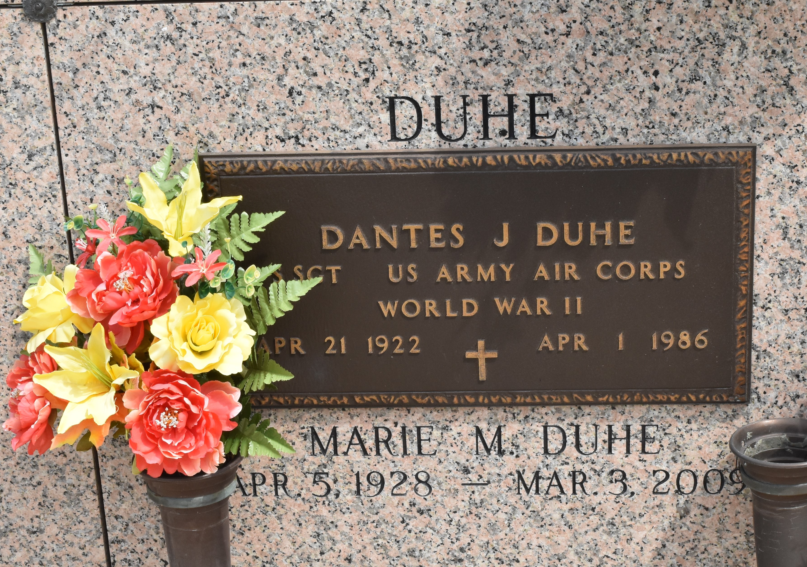

Dantes J. Duhe Sr., 63, was a native of Garyville and a resident of LaPlace. He was a veteran of WWII. He was a member of Disabled American Veterans, Veterans of Foreign Wars, and Blinded Veterans Association. His survivors include his wife, two sons, two sisters, a brother, and two grandchildren. He was preceded in death by his parents, Elysee Duhe and Kenilia Keller Duhe; three brothers, Richard, Melvin, and E.J. Duhe.

An obituary for Mr. Duhe was published in the Morning Advocate, Baton Rouge, LA, on 02 May 1986. It is on file at Broadmoor Branch, Shreve Memorial Library, Shreveport, LA.

Unknown source