Lawrence John Duhe Jr.
December 31, 1957 – January 2, 2016

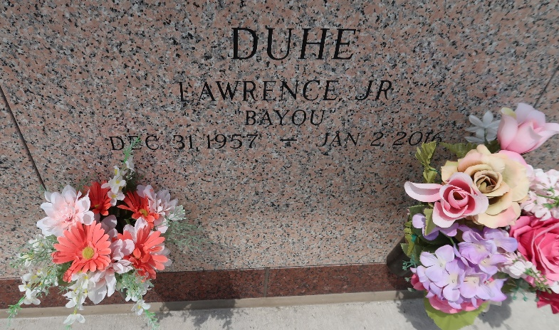

Lawrence John Duhe Jr. was born Dec. 31, 1957, and passed away Jan. 2, 2016, at the age of 58. He was a native and resident of LaPlace.
Duhe is survived by wife Katy Vicknair Duhe; sons Lawrence John Duhe III and wife Meggie, Johnny Paul Duhe and wife Alicia, and Ronnie Duhe; and sisters Kerry Cella and Connie Vicknair.
He will be greatly missed by his grandchildren, Nathan Duhe, Owen Duhe, Jax Duhe, Johnny Duhe Jr. and Cohan Duhe and step-grandchildren, Kiaya, Zeta and Celeste.
Duhe was preceded in death by his parents, Lawrence Duhe Sr. and Shirley Remondet Duhe.
It was Lawrence Duhe's request that all visitors to his funeral wear black and gold in honor of the New Orleans Saints.
A memorial visitation will be held on Friday, Jan. 8 at St. Joan of Arc Catholic Church in LaPlace from 9 until 11 a.m., followed by a Memorial Mass at 11 a.m. Rose Lynn Funeral Services, 1870 Cabanose Ave. in Lutcher, is in charge of the arrangements.
To sign and view the family guestbook, visit roselynnfuneralhome.com.

L'Observateur, LaPlace, Louisiana
Tuesday, January 5, 2016
Contributed by Jane Edson

