Robert F. Duhe
August 26, 1948 – June 8, 2007

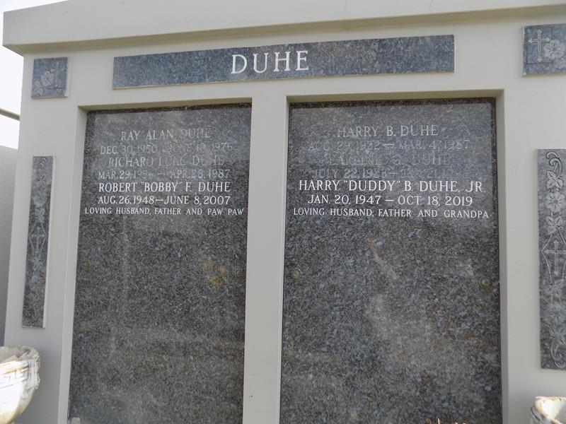

Robert (Bobby) Duhe on Friday, June 8, 2007 at 11:01 AM. Beloved husband of Barbara Champagne Duhe. Father of Michael Duhe. Grandfather of Kimber and Brock Duhe. Godfather of Karen Champagne. Son of the late Harry and Earline Gendron Duhe. Brother of Duddy Duhe and the late Ray Allen and Ricky Duhe. Brother-in-law of Terry Champagne, Steve Heffner and Kathleen Duhe. He enjoyed shrimping and bowling and was an avid Comet and LSU fan. Age 58 years, a native and resident of LaPlace, LA.

Relatives and friends of the family are invited to attend Services. Visitation at Millet-Guidry Funeral Home, 2806 W. Airline Hwy., LaPlace, LA, on Monday, June 11, 2007 from 5:00 PM to 9:00 PM and on Tuesday from 8:00 AM to 9:45 AM, followed by Religious Services at St. Joan of Arc Catholic Church, LaPlace, LA at 10:00 AM. Burial in St. John Mem. Gardens in LaPlace, LA.
Times-Picayune, The (New Orleans, LA)
Monday, June 11, 2007
Contributed by Jane Edson

