Ruth Judy (Jacob) Duhe

February 22, 1929 – February 23, 2019

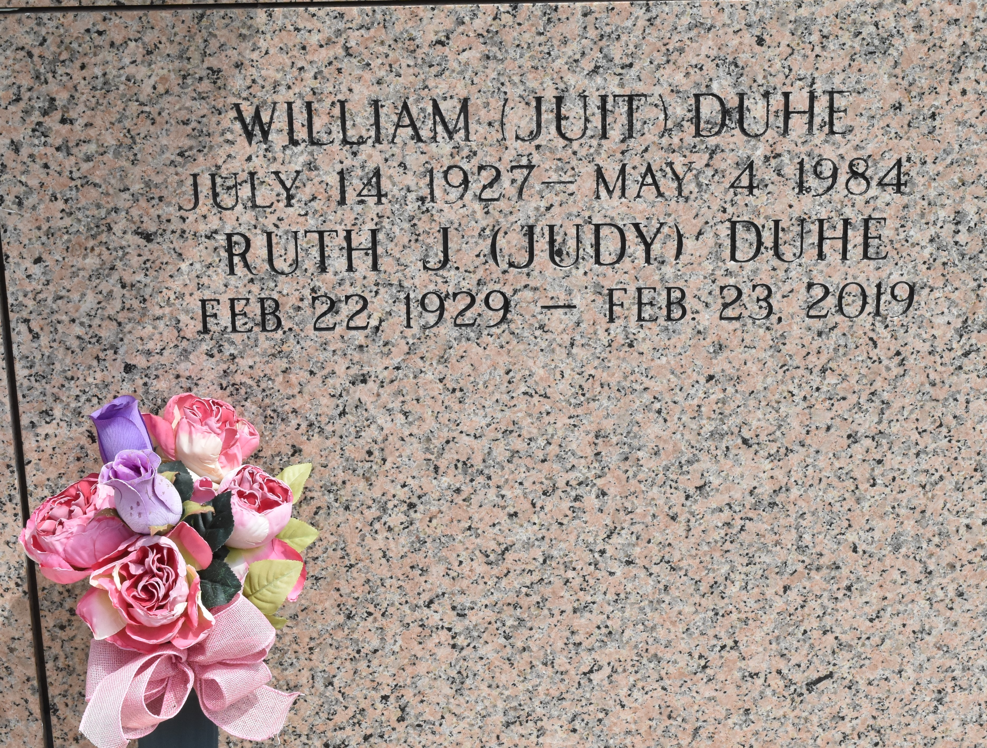

Ruth J. Duhe (Judy Ole Ma), passed away on Saturday, February 23, 2019. She was 90 years old and a life long resident of LaPlace, LA.

She is survived by her daughters Judy D. Montz, wife of Carl Jr., Mary Diane (Deekie) Duhe, Sharon D. Graugnard, wife of Emile Sr., and Jane D. Weinert, Wife of Eugene Jr. “Old Ma” is also survived by her grandchildren, Carl Montz III and wife Tanya, Jeffrey Montz, Kevin Montz, Emile Graugnard, Jr. and wife Heather, Amie G. Navarre and husband Lawrence and her great-grandchildren, Dustin Montz, Emile Graugnard III, Evan and Aubrey Navarre.

She was preceded in death by her husband, William (Juit) Duhe; parents, Ada Vicknair and Ludger (Moonlight) Jacob; sisters, Marguerite (Lou) Maggio, Annabelle (Connie) Vicknair and Rita (Hickey) Vicknair. She was also preceded in death by Hunter and Peyton Graugnard and a set of unborn twins.

Visitation will be on Wednesday, February 27 at St. Joan of Arc Catholic Church, LaPlace, LA from 9:30am until funeral time. A Mass of Christian Burial will be held at 11:30am with burial following at St. John Memorial Gardens Cemetery in LaPlace, LA.

The family would like to offer gratitude to Dr. Christy Montegut for his support during this time.

Rose Lynn Funeral Home, Lutcher, Louisiana