Sharon ‘Sally’ Duhe

February 13, 1950 – January 18, 2022

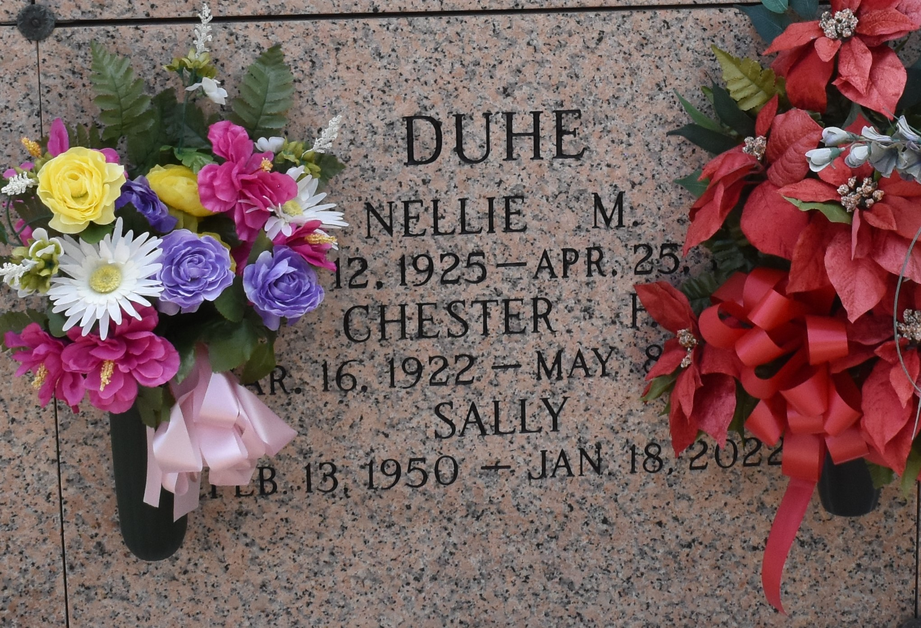

Our beautiful mom, Sharon "Sally" Duhe, departed this world after a long, brave battle with Parkinson's Disease Dementia on January 18, 2022 at the age of 71. She was born on February 13, 1950 and raised in Reserve, Louisiana by her loving parents, Chester and Nellie Duhe.  
 Having a big heart and a unique character, she was easy to love. Her love for Jesus Christ and His Word reflected in the way she treated others. She was a long-time resident of Dutchtown, raised not only her five children, but also took in extended family and friends needing a temporary home. She was generous with her time and love, selflessly caring for others. Sally enjoyed working for Baton Rouge Coca-Cola for many years, so dedicated that Pepsi products weren't even allowed in the house. In retirement, babysitting and daily chauffeuring grandchildren brought her joy and fulfillment. In 2014, she reunited with her high school sweetheart, who couldn't wait to marry her. Nolan treated her like a princess, loved her beyond measure, and cared for her until her last breath. Sally's unique, abundantly kind personality was contagious and will be missed by many.  
 Sally is survived by her loving husband, Nolan J Duhe Jr; sons and daughters-in-law, Perry, Kyle (Jessica), Chris (Margo), and Lane (Brittany) Comeaux; daughter, Lori Comeaux Encalade (Ruble); grandsons Jake, London, Luke, Slade, and Laken Comeaux, Jude and Alex Encalade; granddaughter, Ava Encalade; sisters Lynne Bernard and Maria Cambre; brothers, Norman Cambre and David Harrison; numerous nieces, nephews, brothers and sisters in-law, stepchildren, and step grandchildren; her best friend for 50 years, Debby Pittman.  
 Services will be held on Saturday, January 22, visitation from 9 to 11 am, memorial service will begin at 11 am. The Vault Event Center, 36506 Oak Plaza Ave, Prairieville.  
 Our family gives special thanks to Nolan, the staff of Bridgeway Hospice, and Ascension Oaks Nursing for being dedicated to the love and care of our mom until the last moment.

Published by Legacy Remembers from Jan. 21 to Jan. 22, 2022