George A. Dybendal Jr.

May 8, 1967 – March 26, 2002

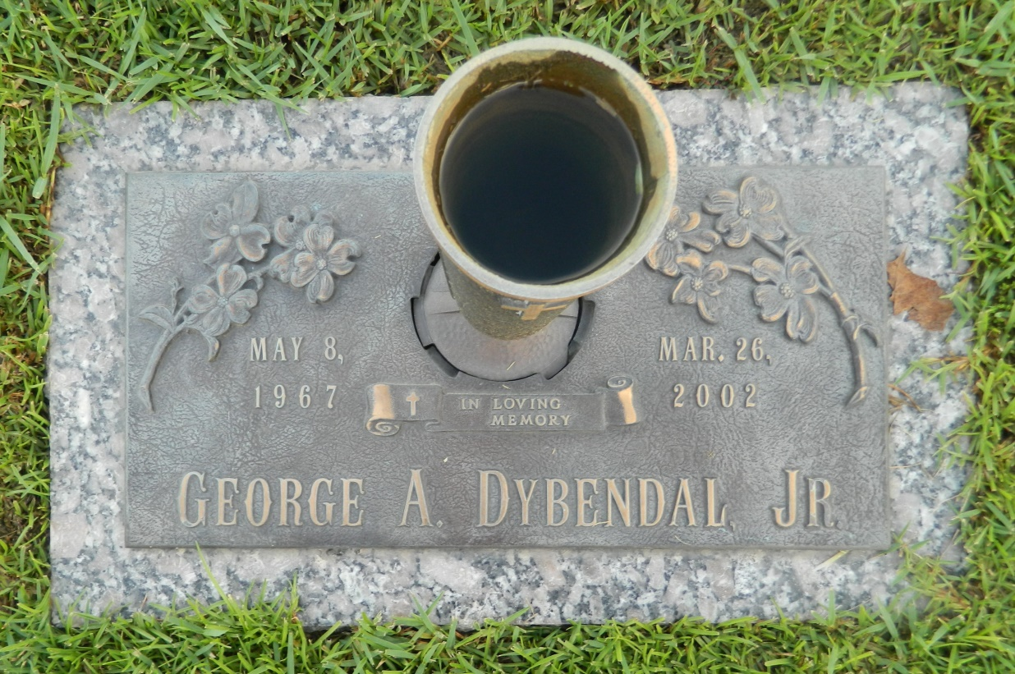

Photo by Margie Pearce

George A. Dybendal, Jr On Tuesday, March 26, 2002 At 11:57 A.M. Beloved Son Of Kathy Dybendal And The Late George Dybendal Sr. Brother Of Patricia Mctyre, Virginia Dybendal And Angela Murray. Also Survived By Nieces And Nephews. Age 34 Years, A Resident Of Laplace, La. Relatives And Friends Of The Family Are Invited To Attend The Funeral Services At Millet-Guidry Funeral Home, 2806 W. Airline Highway, Laplace, La. On Thursday, March 28, 2002. Followed By Religious Services In The Funeral Home Chapel At 10:00 A.M. Burial In St. John Memorial Gardens Cemetery, Laplace, La. Visitation From 8:30 A.M. On Thursday Until Service Time.

Times-Picayune (LA); no date listed