Ashley Michael Edler
September 20, 1978 – October 14, 2010

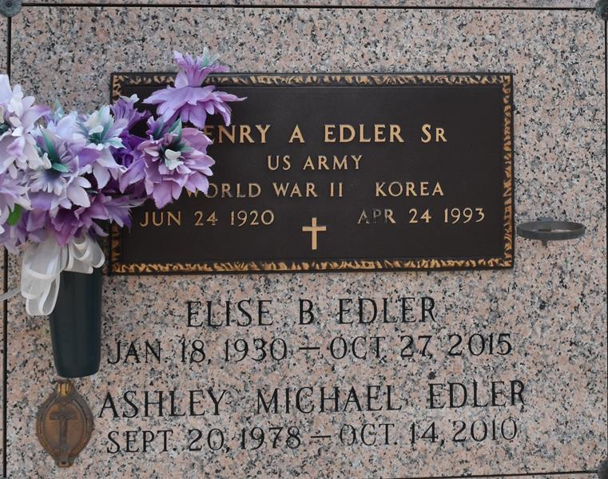

Ashley Michael Edler passed away on Thursday, October 14, 2010. Beloved son of Henry, Jr. and Manya Vicknair Edler. Brother of Casey Paul Edler. Grandson of Elise Edler and the late Henry Edler, Clinton and Elmire Vicknair. Also survived by aunts, uncles and cousins. Age 32 years. A native and resident of LaPlace, La.
Relatives and friends are invited to attend services. Visitation at Millet-Guidry Funeral Home, 2806 W. Airline Hwy., LaPlace, La. on Monday, October 18, 2010 from 9:00 am until 10:45 am. Followed by Mass at St. Joan of Arc Catholic Church, LaPlace at 11:00 am. Burial in St. John Memorial Gardens, LaPlace. In lieu of flowers, Masses are preferred.

The Times-Picayune, New Orleans, Louisiana
Oct. 17, 2010

