Lionel J. Edler Jr.
September 22, 1932 – April 29, 2008

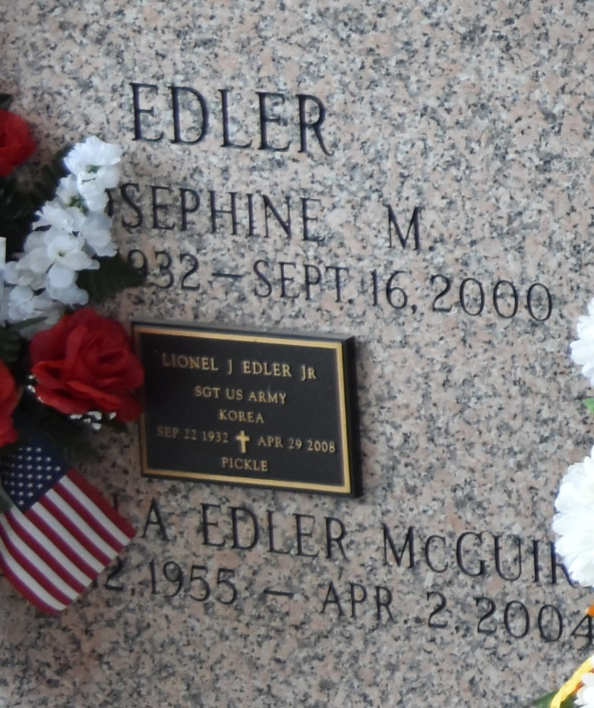

Lionel (Pickle) Edler, Jr. on Tuesday, April 29, 2008 at 12:44 P.M. Beloved husband of the late Josephine (Josie) Milioto Edler. Father of Marlene Duhe, Rory and Scott Edler and the late Angela McGuire. Grandfather of Staci and Troy Duhe, Jeanne, Amber and Cortny Edler, Scott and Nicole Edler and James McGuire. Great-grandfather of Austin and Ashton Simon, Dominick George and Hunter and Ella Champagne. Brother of Brenda Terrio and Carol Montz.
Special thanks to Ethelene Hampton for loving care and concern. Age 75 years. A native and resident of LaPlace, Louisiana.
Relatives and friends of the family, also V.F.W. Post 3338 are invited to attend services. Visitation at Millet-Guidry L.L.C. Funeral Home, 2806 W. Airline Highway, Laplace, LA. on Friday, May 2, 2008 from 8:30 A.M. to 10 A.M. Followed by Religious Services at the Funeral Home Chapel at 10:00 A.M. Burial in St. John Memorial Gardens Cemetery, LaPlace, LA.

The Times-Picayune, New Orleans, Louisiana
May 1, 2008

