Randy Joseph Edler
October 15, 1959 – December 27, 2011

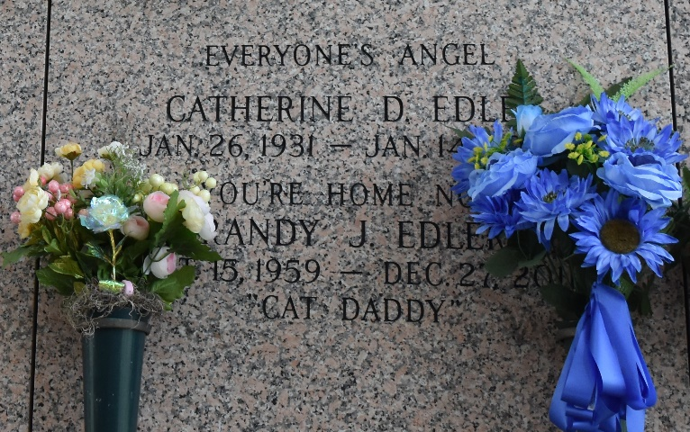

Randy Joseph Elder (Cat Daddy), born on October 15, 1959, passed away on December 27, 2011. He leaves to cherish his many precious memories his siblings: Phylis Carmack, Annette Cosme, Cheryl Dugas, Roy Elder, Jr., Barry Elder and Danny Elder.
He was preceded in death by his parents: Roy Elder, Sr. and Cathrine Elder; and sisters: Faye Edler and Susanne LaMaster. He was an avid outdoorsman. He loved to spend time in the spillway with his friends and shrimping in Lake Pontchartrain. He was loved by family and friends and will be missed by all. Goodbye Cat Daddy!
Relatives and friends of the family are invited to attend his Memorial Service on Saturday, January 7, 2012, 10:00AM at St Joan of the Arc Church. Interment and graveside services will follow at St John Memorial Gardens, LaPlace, LA. Special thanks to Canon Hospice. Services entrusted to the Caring Staff of Professional Funeral Services, Inc "Divine, A New Dimension of Service" 1620 Elysian Fields Avenue, New Orleans, LA 70117 (504) 948-7447.
The Times-Picayune, New Orleans, Louisiana
January 5 to January 6, 2012

