Evelyn (Kelly) Edwards
March 5, 1947 - December 20, 2024

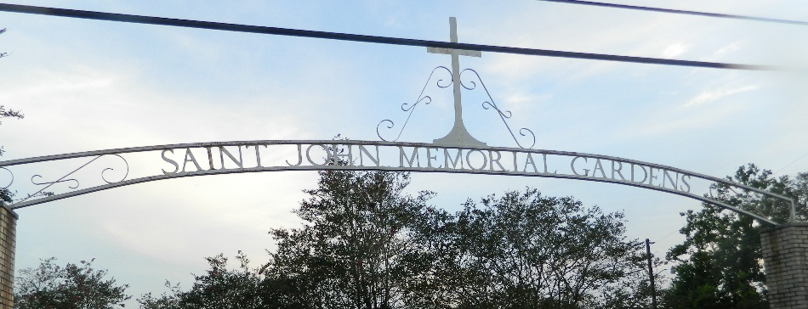

Evelyn K. Edwards, a fierce fighter was born on March 5, 1947, in Modeste, LA passed away on December 20, 2024.
Preceded in death by her loving husband Welmer B. Edwards, her parents Robert and Dorothy Mae Kelly Sr., brothers Willam Kelly and Robert (Ruth) Kelly, Jr., her sisters Myona (Curvin) Henry Sr. and Joanne Simmons, loving daughter-in-law Quintella Chopin and grandchildren J’irmani and Therrill Edwards Jr.
A chef and baker at heart, Evelyn would make any meal put a Michelin Star restaurant out of business. She also loved to decorate her cup with beautiful fruit arrangements that would have you not wanting to touch the cup and just stare at the fruits. She loved to decorate her homes with Christmas, Mardi Gras, Valentine Day, St. Patrick’s Day, and any other holiday decorations she could find all at one time, Festive to say the least, just like the fruits on her cup. And let’s not forget about her hair, it was her crown jewel, and she took great pride in maintaining one of the signature things about her look and personality.
After graduating Leon Godchaux High School in 1972, Evelyn was employed by various employers such as Boyce Machinery, Louisiana Power & Light, St. John The Baptist Parish School System as a substitute teacher, Pepsi Cola and she retired from Elayn Hunt Correctional Center. She accepted Christ at an early age and was a longstanding member of St. Mark Baptist Church.
Evelyn is survived by her loving sons Vince R. (Veronica) Edwards, Duane B. Edwards, Therrill R. Edwards (the late Quintella Chopin and late grandchildren J’irmani and Therrill Edwards Jr.), and loving daughter Trevor L. Edwards. Sister of Lawerence (late Mildred) Kelly Sr., Annie Mae (Charles) Taylor, Patricia (Michael) Kitts, Louise (Anthony) Preyan, Margie (James) Links, Dianne (Nathaniel) White, Darlene (William) White, Sister-in-Law to Ora Lee Kelly, Gregory Simmons, Euguene (Renee) Roussell, Lugene Elois (Phillip) Johnson, Barbara Ann Taylor, Michael (Deborah) Alexis, Denise Lynn Alexis, Aunt Earline Alexander and Uncle Joseph Kelly. She is survived by 30 grandchildren, 28 great-grandchildren and a host of nieces, nephews, three godchildren and other relatives and friends.
A public visitation will be held on Friday, December 27, 2024 from 4-6 pm at Treasures of Life Funeral Services, 315 E. Airline Hwy, Gramercy, La 70052. A celebration of life, love, and legacy will be held on Saturday, December 28, 2024 at St. Mark Baptist Church, 132 Marquez St., Mt. Airy, La 70076. Visitation begins for 8:00 followed by service for 10:00 am. Final viewing prior to start of service. Pastor Oscar Nelson, Sr officiating. Entombment St. John Memorial Gardens, 2205 W. Airline Hwy., Laplace, La. 70068.

Treasures of Life Funeral Services, Gramercy, Louisiana
December 27, 2024

