Vernell Edwards
March 13, 1967 – April 22, 2021

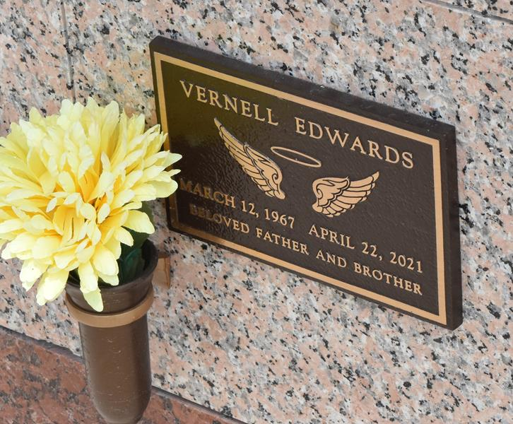

Vernell "Lil Pete" Edwards was born on March 12, 1967 to Lethaniel Edwards, Jr. and the late Patricia Ann Moseman Wallace at Charity Hospital in New Orleans, LA. He was educated in the St. John the Baptist Parish school system. Vernell had a very special persona about himself. He was calm, gentle, funny, charismatic and talented. He was a joy to be around. Vernell loved to sing and was always ready to sing, especially Bob Marley Reggae music. He was good looking, and boy could he dance.
Vernell left Louisiana at the age of twelve and moved to California with his father. There he was introduced to the style of dance called pop-locking. Every summer he would visit us in Louisiana. We would have school hops and there would be talent contests. Vernell would dance and win all the contests. He would come home with bragging rights and some cash. Imagine that! At a very young age, Vernell knew there was something about him that allowed him to capture an audience. Vernell grew up in California and later went to live with his maternal aunt Rena Mae Matthews for a period of time. She looked after him like a son. His two cousins Leon Matthews, Jr. and Dwayne Matthews became his big brothers away from home. His aunt Rena said she is heartbroken over his transition, as Pete was not only her nephew, but he was truly a son to her. Vernell's passion was dancing and singing. He did not need a stage or band to perform. Wherever he was, that became his stage. Vernell sang acapella and made drum sounds with his mouth. He surely knew how to captivate his audience.
Vernell was a gentle giving person and was always willing to help you. His smile was infectious. His style was portrayed with confidence. He was free-spirited and liked to travel. Vernell was adaptable and a survivor. His presence graced his family, and he loved his daughter, parents, siblings, aunts, uncles, nieces, nephews, and cousins. He lived his life without fear on his own terms and without boundaries. He returned to Louisiana in 2019, where he resided in Laplace for a short time. On Thursday, April 22, 2021 in San Francisco, CA, Vernell heard the voice of God tenderly calling him home, as he fell asleep in Jesus' arms.
Vernell leaves to mourn his daughter, Yvonne E. Gammage (Terrence); father, Lethaniel Edwards, Jr.; siblings, Troyla Keller (Tim), Patricia King (Ricky), Renee Payne (Wardell), John Wallace, Jr. and Christopher Wallace; aunts, Rena Mae Matthews, Barbara Polk, Mable (Popsicle) Schofielof and Vita Marie Joseph; uncles, John Edwards, Sr. (Irma) and Joseph Moseman (Lottiebell); nieces, Gabrielle Keller, Mia Edwards, Tirzah Payne, Calen Wallace and Zoe Wallace; nephews, Rupert Dinvaut IV, Kaleb Keller and Tirrek Payne; and a host of other relatives and friends.
He was preceded in death by his mother, Patricia Ann Wallace; maternal grandparents, Rena and Clarence Moseman; paternal grandparents, Lethaniel and Rosemary Edwards; paternal aunt, Carol Ann Edwards; and paternal uncles, Leroy Edwards, Clarence Moseman, Jr. and Donald Moseman.
Vernell "Pete" Edwards will be sorely missed by each and every one whose lives he touched. His memories will live in our hearts forever. A celebration honoring the life of Vernell "Pete" Edwards will be held on Friday, May 21, 2021 at Treasures of Life Funeral Services, 315 E Airline Hwy, Gramercy, LA 70052. Visitation period 9am until start of service at 11am. Private burial.

Treasures of Life Funeral Services, Gramercy, Louisiana

