Amie Lea Englade
May 23, 1985 – May 14, 2004

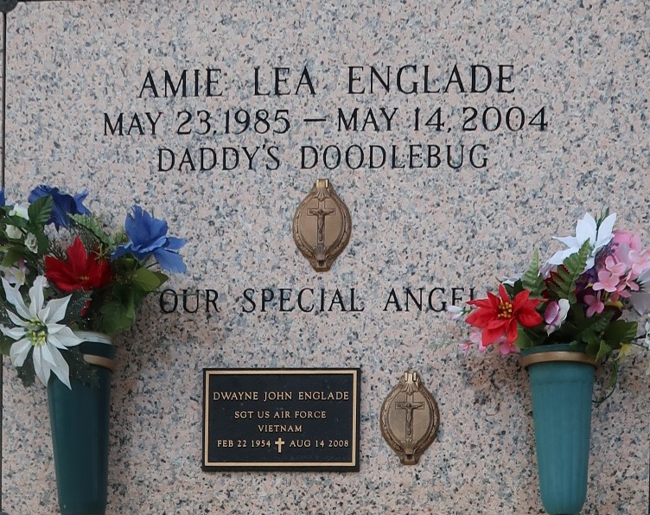

Amie L. Englade On Friday, May 14, 2004 At 4 A.M. Beloved Daughter Of Dwayne Englade And Donna Keen. Sister Of Nathan And Michael Englade. Granddaughter Of Nathan And Mildred Englade, Dorothy Keen And The Late Van Keen. Aunt Of Logan Michael Englade. Age 18. A Native And Resident Of Laplace, La.

Relatives And Friends Of The Family Are Invited To Attend Services. Visitation At Millet-Guidry Funeral Home, 2806 West Airline Hwy., Laplace, La. On Tuesday, May 18, 2004 From 5pm To 10pm And On Wednesday From 8am To 9:45 Am. Followed By Religious Services At The First Baptist Church, 120 Ormond Blvd., Laplace, La. At 10am. Burial In St. John Memorial Gardens, Laplace, La.

The Times-Picayune, New Orleans, Louisiana
May 18, 2004

