Dwayne John Englade

February 22, 1954 – August 14, 2008

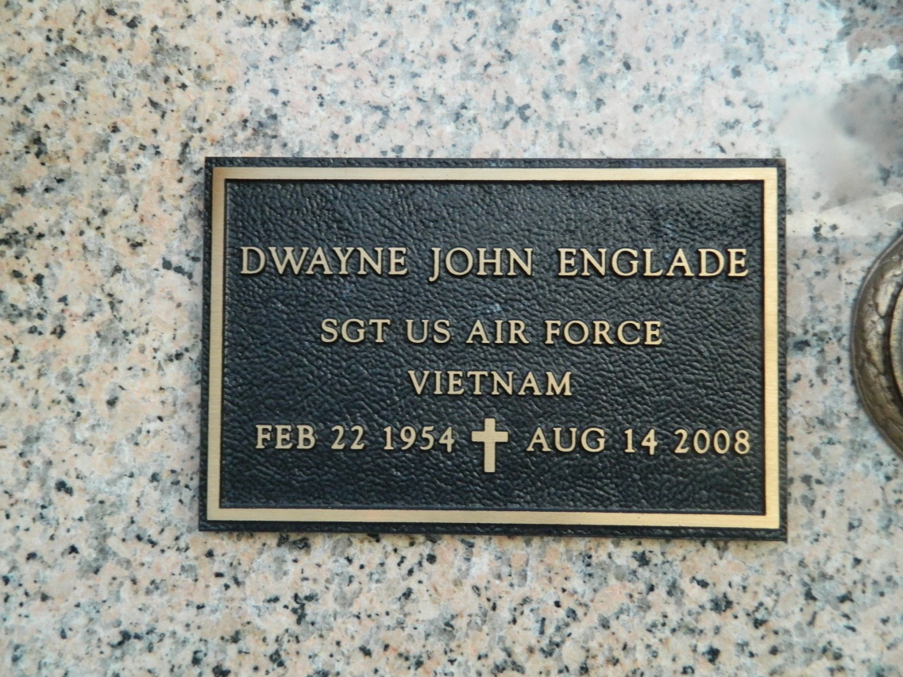

Dwayne (Dee) Englade on Thursday, August 14, 2008 at 11:35 a.m. Beloved husband of Peggy Robichaux Englade. Father of Nathan and Michael Englade and the late Amie Englade, also, Jennifer Cooper, Bonnie, Bridget and Amanda McKinney. Son of Nathan and Mildred Englade. Brother of Jody and Mark Englade. Grandfather of Nash, Faye, John Luke, Logan, Nathan and Tristan. He will be missed by his beloved dog Buddy. Age 54 years. A native and resident of LaPlace.  
  
Services were Tuesday, August 19, at the First Assembly of God Church in LaPlace. Burial to be private at a later date.

L'Observateur (La Place, LA) - Tuesday, August 19, 2008

Contributed by Jane Edson