Ruby (Richoux) Englade
April 1, 1933 – March 14, 2017

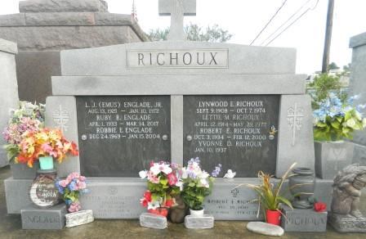

Ruby Richoux Englade passed away on Tuesday, March 14, 2017 at the age of 83. She was a native of New Orleans and a resident of LaPlace. Beloved wife of the late Lester Joseph Englade, Jr. Loving mother of Emery Englade (Mickey), Marlene Englade, Ryne Englade (Suzie) and Karl Englade. Grandmother of Lisa Vicknair, Alicia Duhe, Trustin Remondet, Wesley Remondet, Tiffany Englade, Stephanie Englade, Karlie Englade and the late Robbie Englade. Also survived by many great-grandchildren. Daughter of the late Lettie Hotard and Lynwood Richoux. Sister of the late Robert "Bobby" Richoux (Yvonne).

She was a loving mother, devoted friend and life of the party. She will be greatly missed and forever remembered by all who knew her. The family would like to give a special thanks to the staff of Twin Oaks Nursing Home for their loving care and kindness.

A graveside service will be held at St. John Memorial Gardens Cemetery on Saturday, March 18, 2017 at 10:00 a.m. In lieu of flowers, please consider a donation to the St. John Animal Shelter, 488 W. 2nd St., LaPlace, LA 70068. To view or sign the online guest book, please visit www.milletguidry.com
The New Orleans Advocate (Louisiana)
Mar. 15 to Mar. 18, 2017

