Michelle Ann Engnath
August 18, 1963 – October 27, 2010

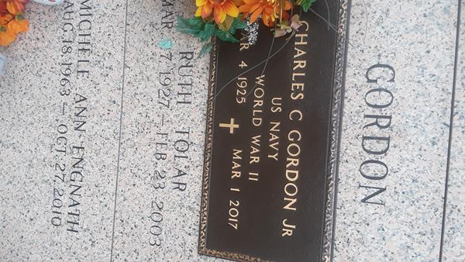

Michele Ann Engnath passed away on Wednesday, October 27, 2010. Beloved mother of Sarah Engnath. Daughter of Paul Engnath, Jr. and Patricia Hardy Williams. Step-daughter of Charles Williams, Jr. Sister of Paula Engnath Montz and Troy Engnath (Ann Acosta). Aunt of Kate, Emily and Grace Engnath. Granddaughter of the late Anita and Clarence Hardy and Lorraine and Paul Engnath. Dear friend of Vicki Hurd and Steve Gant. Age 47 years. A native of Norco, former resident of Clovis, CA and a resident of LaPlace, LA.

Relatives and friends are invited to attend services. Visitation at St. Joan of Arc Catholic Church, 529 W. 5th Street, LaPlace, on Saturday, October 30, 2010 from 11:30AM until 1:30PM. Followed by a Mass at the Church at 1:30PM. Burial in St. John Memorial Gardens Cemetery, LaPlace.

Arrangements by Millet-Guidry Funeral Home, LaPlace.
The New Orleans Times Picayune (LA)
Oct. 29, 2010

