Jesus Orlando Estrada
January 2, 1949 – Mary 21, 2014

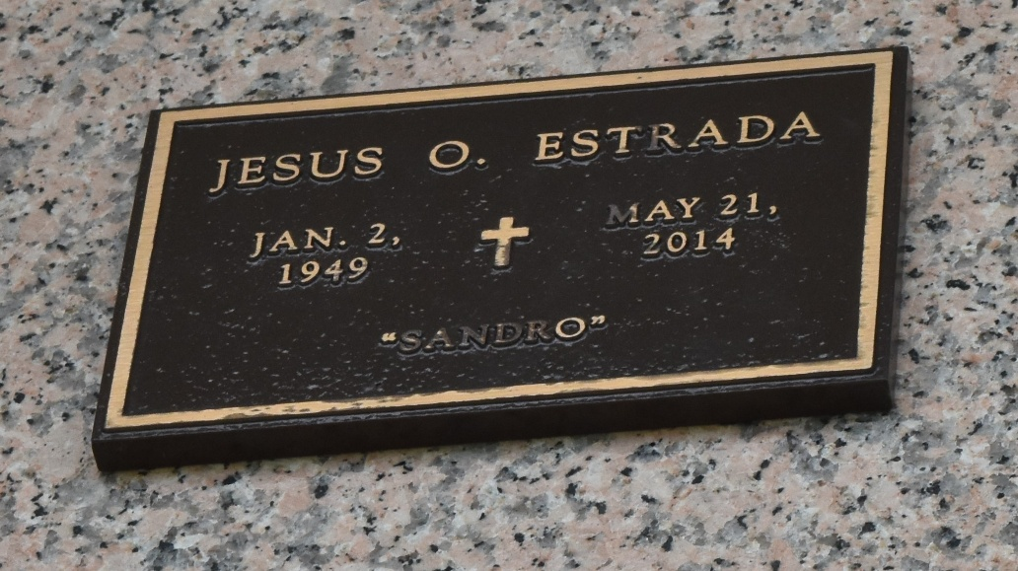

Jesus "Sandro" Orlando Estrada passed away at St. Theresa's Specialty Hospital in Kenner, LA on Wednesday, May 21, 2014.
Beloved husband of Carmen Mendez Estrada for forty-three years. Son of the late Raul Estrada, Sr. and Barbara Trochez Estrada. Brother of Gloria Estrada, Rigo Estrada, Roberto Estrada, Lisseth Madero and Raul Estrada, Jr. Also survived by the Fajardo Family, nieces, nephews and many other loving relatives and friends.
Mr. Estrada was born in Tela, Honduras but spent most of his life in New Orleans, LA before moving to LaPlace, LA approximately twenty-four years ago. After his family, Mr. Estrada's favorite passion was music. He performed as a singer, in both Spanish and English, in several local bands over the past twenty years.
Interment will be private. Arrangements handled by NEPTUNE SOCIETY OF NEW ORLEANS, 3801 Williams Blvd., Kenner, LA.

The New Orleans Advocate, Louisiana
Jun. 6 to Jun. 9, 2014

