Warren Farlough

October 15, 1942 – March 19, 2019

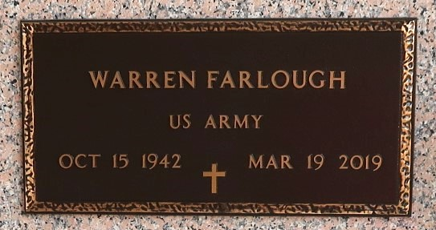

Warren "Pam" Farlough at the age of 77 years old departed this earthly life and entered into eternal rest on Tuesday, March 19, 2019, at Ochsner Medical Center of Jefferson, LA. Devoted husband of Nellie Watkins Farlough of Mt. Airy, LA. Loving father of Darrell Farlough, Marlon (Kia) Farlough, and Durwin (Adriana) Farlough. Brother of Cleveland (Claudia) Farlough and Joseph (Claudia) Farlough of Mt. Airy, LA. Grandfather of Mason Farlough. Also survived by a host of nieces, nephews, other relatives, and friends. A native and resident of Mt. Airy, LA.

Warren was preceded in death by his parents, Rev. J.J. Farlough and Sedonia Farlough. Siblings, Hilda Belvin, Thelma Williams, Harding, Herman, Eldridge, Harold, and Naylon Farlough.

Pastors, officers, and members of the St. John Baptist Church, St. Mark Baptist Church, Providence I Baptist Church, and all neighboring churches are invited to attend the homegoing celebration on Saturday, March 23, 2019 at 11:00 a.m. at the St. John Missionary Baptist Church, 287 Daffodil St., Mt. Airy, LA. Pastor Gary Bolden officiating. Interment in St. John Memorial Cemetery of LaPlace, LA. Visitation will be at Bardell's Mortuary of Mt. Airy, LA on Friday, March 22, 2019 from 3:00 p.m. until 6:00 p.m. and on Saturday, March 23, 2019 at St. John Missionary Baptist Church from 9:00 a.m. until service time. Bardell's Mortuary of Mt. Airy, LA in charge. Information: (985) 535-6837.

The New Orleans Advocate, Louisiana

Mar. 21 to Mar. 23, 2019