Jane (Fernandez) Faucheaux
December 5, 1932 – March 11, 2020

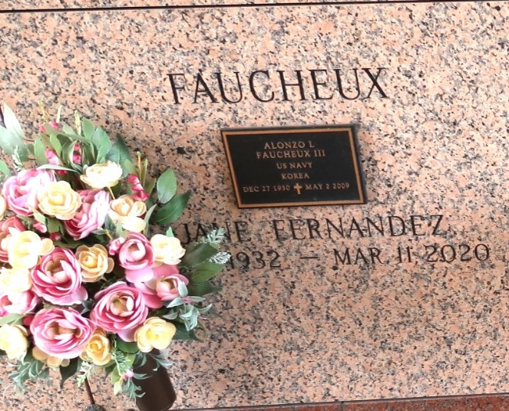
Jane Fernandez Faucheux passed away on March 11, 2020 at her home in Montz, Louisiana. She was a loving and devoted wife and mother, and "Mimi" to her grandchildren and great grandchildren. She was preceded in death by her husband of 54 years, Alonzo Louis "Al" Faucheux III, providing loving care for him during an extended illness prior to his death. She is blessed to be survived by all five of her children and their spouses, including Lonnie and Susan Faucheux, John and Nancy Faucheux, Alicia and Stan Vial, Yvette and Jacques Levet, and Stephanie and Larry Bleakley, as well as 12 grandchildren, 5 great grandchildren, and 2 brothers, Thomas Fernandez, Sr. and Richard Fernandez. She was preceded in death by her parents, Arthur and Gertrude Fernandez and another brother, Arthur, Jr.
The family would like to thank Jane's loving caregivers, Karen Sterling and Mary Breaud, who have been so helpful, patient, and kind to her during her final months.
Relatives and friends are invited to attend the visitation at Millet-Guidry Funeral Home, 2806 W. Airline Hwy, LaPlace on Monday, March 16, 2020 from 6:00 p.m. to 8:00 p.m. and on Tuesday, March 17, 2020 at St. Joan of Arc Catholic Church, 529 W. 5th St., Laplace from 10:00 a.m. to 11:30 a.m. followed by a Funeral Mass at 11:30 a.m. Interment in St. John Memorial Gardens Cemetery, LaPlace.
Millet-Guidry Funeral Home, LaPlace, Louisiana
March 14, 2020

