Mary Frances “Frannie” (Colligan) Feller

January 14, 1938 – September 28, 2004

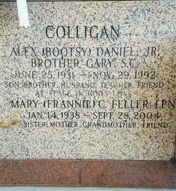

Photo by mbc

Frannie Feller, 66 (Mary F Colligan)

A retired licensed practical nurse and a resident of New Orleans for the past 30 years, she died at 10:30 a.m. Tuesday, Sept. 28, 2004. She was 66 and a native of Baton Rouge. She was the beloved mother and mother-in-law of Edward C. Feller Jr., Marion "Mike" and Lisa Feller and Andrew and Patty Feller, all of Jacksonville, Ill.; grandmother of Candace, Haley, Ryan and Laura; and daughter of the late Alex Daniel Colligan Sr. and Anna Mae Braud Colligan. Also survived by Anna Mae and Neil Doucette, John and Loucille Colligan and Janelle Colligan Hanna. Preceded in death by Judson W. Hanna Jr., Kathleen Mitchell, Alex Daniel Colligan Jr., Judson Worth Hanna Sr., Tammy Colligan and Colby Vaughn. She was raised at St. Joseph Academy and went to nursing school. She worked at Louisiana School for the Deaf, Baton Rouge General Hospital and Mercy Hospital in New Orleans. She will be missed by all who loved her. Visitation at Millet-Guidry Funeral Home, 2806 W. Airline Highway, LaPlace, from 6 p.m. to 10 p.m. Thursday, Sept. 30. Visiting in the funeral home chapel from 10 a.m. until religious service at noon Friday, Oct. 1. Burial in St. John Memorial Gardens, LaPlace.

Advocate, The (Baton Rouge, LA)
Thursday, September 30, 2004
Contributed by Jane Edson

