Terence Abram Fenroy Sr.
April 17, 1983 – December 21, 2020

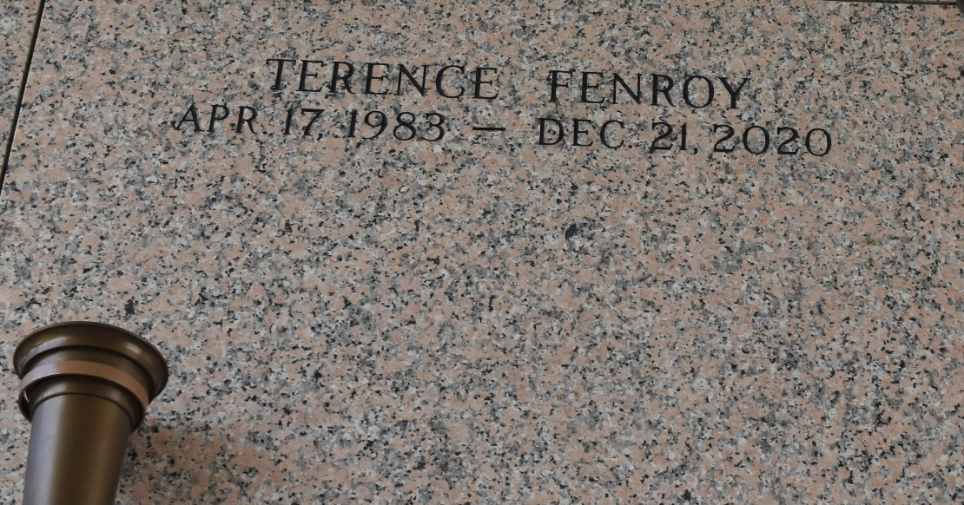

Terence Abram Fenroy Sr., departed this life on Monday December 21, 2020 at the age of 38. Terence is survived by his son Terence Abram Fenroy Jr., parents Abram and Gwenesta Fenroy, brother of Trevor (Stacy) Fenroy, Trevell (Victoria) Fenroy, his twin Travaris Fenroy. Terence is also survived by his aunts, uncles, nieces, nephews and a host other relatives and friends.
Terence is preceded in death by his grandfather, Isadore Breaux, his grandmother Olivia Fenroy Carter and his sister Toya Fenroy Ellis. Celebration
Service on Monday December 28, 2020 at Fresh Faith Worship Center 1114 E. Harding St, Destrehan, La. at 11:00am. Bishop Otis Kenner Officiating. Interment in St. John Memorial Laplace, LA Due to CDC (Covid19) Restrictions Seating Is Limited, Mask and Social Distancing Are Required. Professional Services entrusted to the Caring Staff of Hobson Brown Funeral Home 134 Daisy St. Garyville, La 70051 985-535-2516.
The Times-Picayune, New Orleans, Louisiana
Dec. 26, 2020

