Gloria (Keller) Ferrygood
January 18, 1954 - June 28, 2023

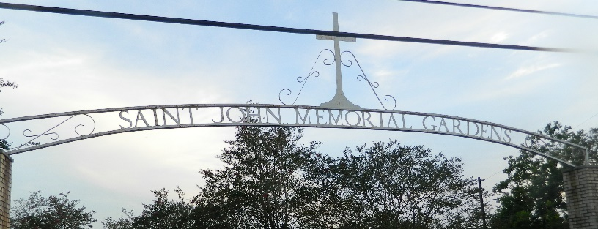

On June 28, 2023 at 11:02pm, Gloria Keller Ferrygood was called home to eternal rest at Ochsner Hospital in Kenner, LA. She was born on January 18, 1954 to the late Hilda Keller (Joseph Keller) And Wilson Placide Sr. Gloria was married to Larry Ferrygood and to this union 3 children were born Lataina Keller (Arlen Harvey), Renee Keller (Lendaz Walters) of Lutcher, LA. and Andraneka Keller (David Jones Jr.) Laplace, LA.
She was baptized at an early age at Our Lady of Grace Catholic Church on River in Reserve, LA where she worshiped and became a choir member. She later joined Tchoupitoulas Chapel in Reserve, LA where she was an active member since 2004 until she was not able to continue singing on the praise team.
She graduated from Leon Godchaux High School, and afterward attended Delgado Community college. She also attended Grambling State University where she also majored in music. She taught many students' music, but her favorite was teaching students how to play the piano. Her Favorite song she always played was 'Oh When the Saints Go Marching In.' She was multi-faceted in playing different instruments. However, the piano was her favorite instrument. She worked at Charity Hospital in New Orleans, LA, she also worked as a security Guard at Bayou Steel in Laplace, LA for years.
Gloria was devoted Christian. She loved going to worship the Lord. She also loved having fun with her family, dancing, playing bingo, going to the casino, going to football games, and marching in parades where she was a chaperone in her spare time. She always looked forward to spending time with her grandkids. Her joyful spirit will truly be missed.
Gloria leaves to cherish her memories, three daughters Lataina Keller, Renee Keller, and Andraneka Keller, Her Eleven grandchildren Nyijai Keller, Dominique Fultz, Lendaz Ra'Naja and Radazmon Walters, Juancheus and Nikayah Washington, Devron Pittman Jr, Nor'Lani, Nor'Lana and Nor'Ryah McClain. Her 6 great grandchildren Khazlee Bowser, Kynzlee, Khaiyne and Kuasyi Keller, and Syn'Cere Saunders. Her 3 sisters Racheal Placide, Cheryl Davis, and Karen Landry. Her 7 brothers Terrance Placide, Wilson Placide Jr., Perry Placide, Kendall and Darrly Taylor, and Rodney and Randall Joseph. Her 2 aunts Lois Bright and Theresa Young, the late Margie Young, Freddie Young, and Pensacola Young, 2 godchildren Elizabeth and Derrick Bright. Her 2 God Parents Ollie Anderson and Paul Vampram. Her 6 sisters in law and 8 brother in laws, and a host of nieces and nephews and other relatives and friends.
She was preceded in death by her parents Hilda Keller and Joseph Keller (Wilson Placide Sr.) and her husband Larry Ferrygood, the late Norah and Agnes Young, the late Margie Young, and the Late Freddie Young Sr.
Relatives and friends of the family, Pastors, Officers and Members of Tchoupitoulas Chapel and all neighboring churches are invited to the Celebration of Life at 11:00am on Saturday, July 15, 2023 at Tchoupitoulas Chapel, 1022 LA-44, Reserve, LA 70084. Rev. Lionel Murphy, Pastor-Officiant. Visitation 9:00am until time of service at the above-named Chapel. Interment St. John Memorial Gardens, LaPlace, LA. Final Arrangements Entrusted to Patrick H. Sanders Funeral Home & Funeral Directors, Inc. 605 Main Street, LaPlace, LA 70068. 985-359-1919.
Obituary published on Legacy.com by Patrick H. Sanders Funeral Home & Funeral Directors, Inc - LaPlace on Jul. 14, 2023.

