Lionel George Fisher Jr.
July 16, 1951 – August 28, 2015

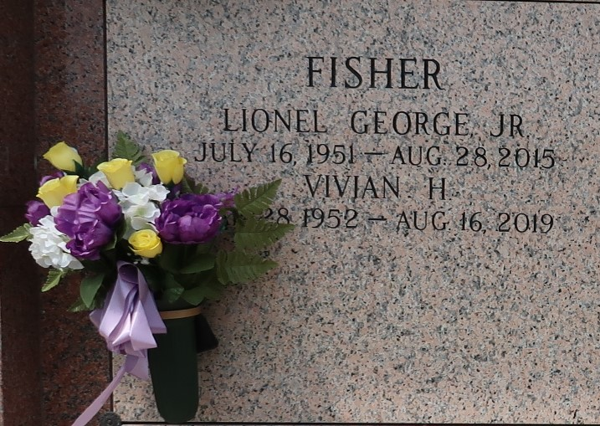

Lionel George Fisher, Jr. passed away Friday, August 28, 2015 at the age of 64, a lifelong resident of LaPlace, LA: he is survived by his loving wife of 39 years, Vivian Hymel Fisher. He is also survived by his children; Lionel (Lonnie) Fisher, III wife Brandi, and Allison Fisher Roy husband Casey, his grandchildren Reese and Cullen Fisher, Hannah and Allison Roy. He is preceded in death by his parents Lionel George Fisher, Sr. and Ruby Chenevert Fisher.
Relatives and friends as well as members of the Bonnet Carre Rod and Gun Club, Dow Chemical, and South Central Louisiana Technical College are invited to attend the Funeral Mass at Ascension of Our Lord Church, 1900 Greenwood Dr., LaPlace on Tuesday, September 1, 2015 at 12:00 noon. Visitation in church from 10:00 a.m. until 12:00 noon. Interment in St. John Memorial Gardens Cemetery. Arrangements by Millet-Guidry Funeral Home. In lieu of flowers, Masses preferred. To view or sign the online guest book please visit www.milletguidry.com.

The New Orleans Advocate, Louisiana
Aug. 29 to Sep. 1, 2015

