Vivian (Hymel) Fisher
March 28, 1952 – August 16, 2019

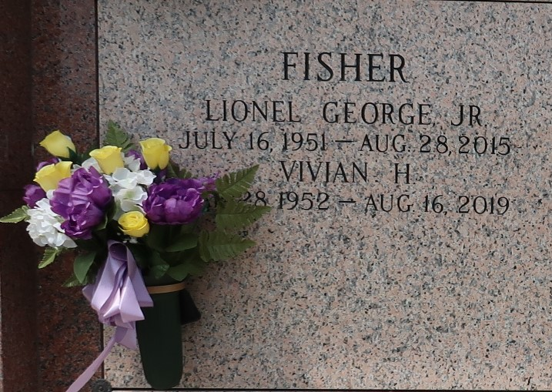

Vivian Hymel Fisher, passed away on Friday, August 16, 2019 at the age of 67, a lifelong resident of LaPlace, LA. Loving wife of the late Lionel Fisher, Jr. Loving mother of Lionel “Lonnie” Fisher, III (Brandi) and Allison Fisher Roy (Casey). Grandmother of Reese and Culle Fisher and Hannah and Allison Roy. Daughter of Maude Hymel and the late Russel Hymel, Sr. Sister of Russel Hymel, Jr. (Cindy) and Kent Hymel (Lola).
Relatives and friends are invited to attend the Funeral Mass at Ascension of Our Lord Catholic Church, 1900 Greenwood Dr., LaPlace on Wednesday, August 21, 2019 at 12:00 p.m. Visitation at church from 10:30 a.m. to 12:00 p.m. Interment in St. John Memorial Gardens Cemetery. Arrangements by Millet-Guidry Funeral Home.
Millet-Guidry Funeral Home, LaPlace, LA
August 20, 2019

