Deshaud Denorris Fluence
May 30, 1988 – October 7, 2025

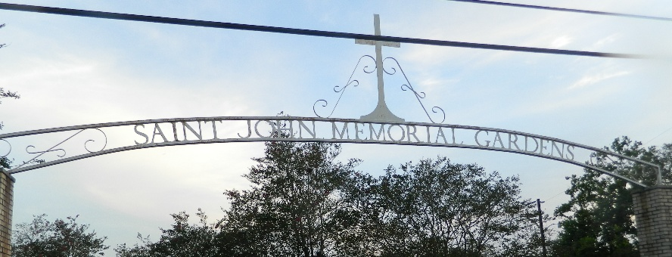

On May 30, 1988, Daphney Armant Fluence and Denorris Fluence welcomed their only child, Deshaud Denorris Fluence, into the world, a son whose energy could fill any room and whose smile could light up the darkest day. From the very start, he was special. He brought laughter, love, and a spark that made everyone around him feel alive. To those who knew him, he was “Shaudy Baby.” To his parents, he was their pride and joy. To his children, he was simply Daddy — their superhero in sneakers, always full of jokes, always full of love.
On Tuesday, October 7, 2025, Deshaud’s earthly journey came to a close as he entered his eternal rest. Though gone too soon, his spirit remains as bright and unforgettable as ever. Deshaud was baptized at an early age at King Triumph Baptist Church in Lutcher, Louisiana, under the leadership of the late Pastor Versey Fluence. He was educated in the St. John Parish School System and graduated with the Class of 2006 from East St. John High School. Later, he continued his education with Louisiana Green Corps, where he earned his degree. In life, Deshaud worked hard and laughed harder. Whether on the job or just hanging with family, he gave every moment his full personality. His most recent employment was with 1-800-GOT-JUNK, where he served as a delivery driver.
Deshaud was united in marriage to Daranisha Ingram Fluence. He was the proud father of four children — Kholbi, Tru, Legend, and Prime — who were the pride and joy of his life. They were his heart walking outside his body, the reason he kept pushing forward, no matter what.
He leaves to cherish his precious memories his loving parents, Daphney Armant Fluence and Denorris (Freida) Fluence; his wife, Daranisha Ingram Fluence; his children, Kholbi, Tru, Legend, and Prime; his aunts and uncles, Marie (Michael) Clayton, Sonja (Leroy) Mitchell, Aaron (Shelby) Lewis, Norbert (Mildred) Armour, Carolyn (Anthony) Joseph, Mary (Kevin) Jackson, Judy (Renard) Dumas, Michael (Vickie) Lee, Doris Fluence, and Angela Walker; his godparents, Wallace and Carmen Batiste; his devoted friend, Brittany Howard; his godchildren, Zaki Mitchell, Ramone Lathers, Me’Khi Clement, Malayah Edwards, and Jayce Lee; and his father-and mother-in-law, Darryl and Andrian Ingram, along with countless cousins, relatives, and friends who will forever love him.
He was preceded in death by his child, Baby Fluence; maternal grandparents, Norbert and Carol Armant; paternal grandparents, James and Leola Lee; uncle, Thaddeus Armant; aunt, Gloria Wallace; and godparents, James and Letha Fluence.
Deshaud had a presence you couldn’t miss. His smile, confidence, and style lit up every room he entered. Whether he was cracking a joke, sketching a new idea, or putting together a sharp outfit, he moved through life like it was his runway bold, creative, and unapologetically him. He was one-of-a-kind full of love, art, and laughter. He never met a stranger, only friends he hadn’t gotten to know yet. His energy was magnetic, his spirit unforgettable, and his light lives on through every smile, every memory, and every heartbeat that still says his name.
A Gathering of Family & Friends will be held on Friday, October 24, 2025 from 5pm to 7pm at Treasures of Life Funeral Services, 315 E. Airline Hwy., Gramercy, LA 70052. Deshaud's Celebration of Life will be held on Saturday, October 25, 2025 at Choice International Family Outreach Worship Center, 516 E. Airline Hwy., LaPlace, LA 70068; visitation 8am to 10am followed by the service at 10am. Entombment St. John Memorial Gardens, 2205 W. Airline Hwy., LaPlace, LA 70068.

Treasures of Life Funeral Services, Gramercy, Louisiana
October 24, 2025

