Geraldine Fluker
December 14, 1940 – November 30, 2021

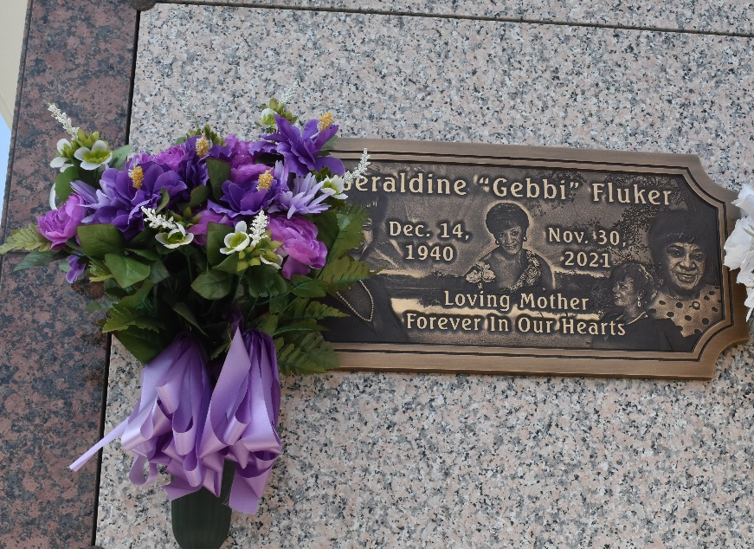

Geraldine "Gebbi" Fluker, a retired nurse assistance and Dialysis Tech for 35 years of service, entered into eternal rest on Monday, November 30, 2021. Daughter of the late Irene Fluker and Calhoun Fluker Sr., Mother of Patrice (Keith, Sr.) Wilson, Kendall, Sr. (Vanette) Andrews, Kermit, Sr (Reianda) Fluker, and Ernest (Lisa)Dents whom she reared as her own, Sister of Rose Mary Valentine. Geraldine is also survived by 9 Grandchildren, 3 great grandchildren, 2 god children and a host of other relatives and friends.
Celebration services on Monday, December 6, 2021, at 10:00 at Milesville Memorial C.O.G.I.C. 129 Apple St. LaPlace, La. Visitation on Sunday, December 5, 2021 from 5 - 7 pm and on Monday from 8 am until service time. Rev Donald Ray August Officiating. Interment in St. John Memorial Laplace, La. Due to CDC (Covid-19) restrictions seating may be limited, mask and social distancing are required. Professional Services entrusted to the Caring Staff of Hobson Brown Funeral Home. 134 Daisy St., Garyville, La 70051. 985-535-2516.
The Times-Picayune (New Orleans, Louisiana)
Dec. 4 to Dec. 6, 2021

