Alvin Louis Fobb

September 17, 1961 – March 3, 2011

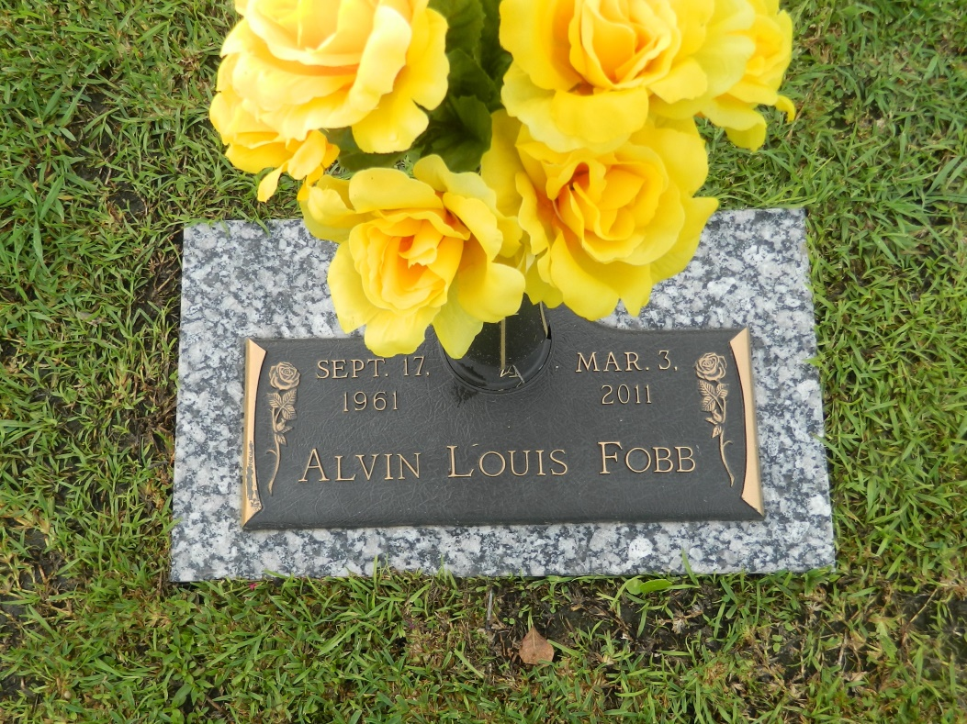

Alvin Fobb departed this life on Thursday, March 3, 2011. Son of Mrs. Loretta and the late Shelton Fobb, Jr. Father of Lynzee Anthony and Andrea Stewart. Fiancé of Beverly King. Also survived by 4 sisters, 5 brothers, 3 grandchildren and a host of other relatives and friends. Age 49. A native and resident of LaPlace, LA.  
  
Pastor, officers, and members of Mt. Calvary Baptist Church and all neighboring churches are invited to attend the Funeral Service on Thursday, March 10, 2011 at the above named Church, 127 3rd St., LaPlace, LA, at 11:00am. Visitation from 9:00am until service time.  
  
Service Entrusted to: Hobson Brown Funeral Home, 134 Daisy St., Garyville, La., 70051, (985) 535-2516

Times-Picayune, The (New Orleans, LA) - Wednesday, March 9, 2011

Contributed by Jane Edson