Herfert Fobb Sr.
March 16, 1920 – December 9, 2018

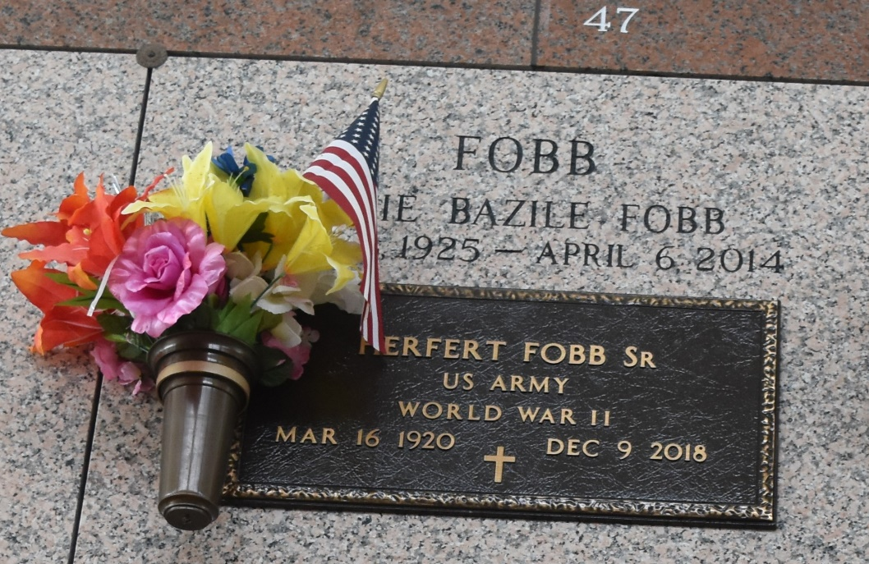

Bro. Herfert Fobb, Sr., Age 98, passed away peacefully at his home on Sunday, December 9, 2018 surrounded by his family. Husband of the late Onie Fobb for 69 wonderful years. Father of Herfert Jr, Vader, Claudia Peggy, Stuart, Jerome and the late Rev. Leonard, Larry, Kevin, and Cornelius Fobb. Bro. Fobb is survived by 27 grandchildren and 54 great-grandchildren and 1 Great great grandchild, brother and sisters and a host of Relatives and friends.
Relatives and friends are invited to attend the homegoing celebration on Saturday December 15, 2018 at 1:30 a.m. at Rising Star B.C. 620 Cardinal St., Laplace, La. 70069. Visitation at 10 am until service time. Rev. Donald Ray August Officiating. Interment in St. John Memorial, Laplace, LA. Professional services entrusted to the caring staff of Hobson Brown Funeral Home, 134 Daisy St. Garyville, La 70051. 985-535-2516

TheNewOrleansAdvocate.com
Dec. 13 to Dec. 15, 2018
Contributed by Jane Edson

