Rodger Dale Ford Sr

December 3, 1944 – March 31, 2015

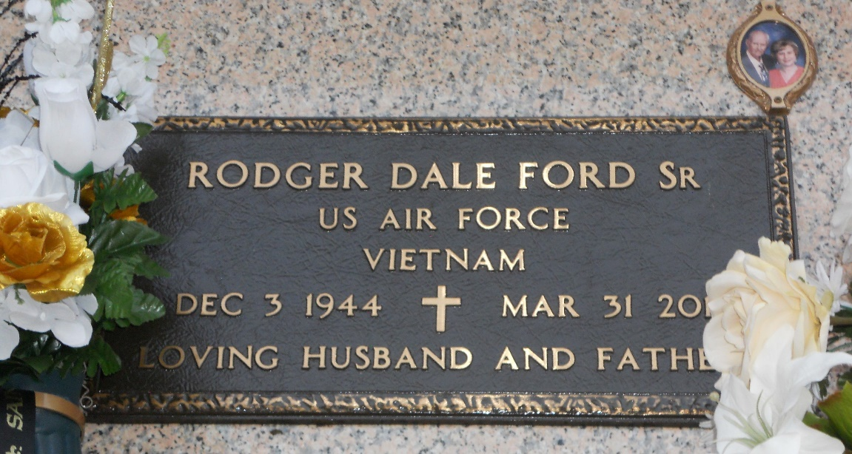

Photo by Team T Lo

Rodger Dale Ford Sr. passed away on Tuesday, March 31, 2015 after a long illness. He was a native of Mansfield, La and a longtime resident of LaPlace, La. Rodger was the loving husband to Mary Ann Bautsch Ford. Together they were parents to 4 children; Rodger Dale Ford Jr. (Danielle), Cynthia Lynn Ford Barrios (Todd), Thomas Matthew Ford (Heather) and James Bellizare Ford (Amanda). He was the proud grandfather of 14 grandchildren; Holly, Cody, Cory, Kerry, Casey, Christopher, Madison, Brock, Bradley, T.J., Aidan, Bryce, Elizabeth and Michael and one great- granddaughter Brynlee. Rodger was the son of the late James Lee Ford and Lovella Isles and the late David Isles Sr. He was the brother of Janice Hull, Carolyn Wright, Vicki DuVall, Annette Lynch, Kathy Bryant and David Isles Jr.

He is survived by his Godparents and in-laws Teresa and Tommy Bautsch. Rodger served in the US Air Force in Germany during the Vietnam War. For many years he worked for National Airline and Pan American Airline, he later went on to own his own sign company. Rodger was a devout catholic who was a member of the neocatechumenal way for 30 years. He loved fishing, playing the guitar, singing, art, watching movies and spending time with his grandchildren that he loved so dearly.

Relatives and friends are invited to attend a wake at H.C. Alexander Funeral Home, 821 Fourth St. Norco, La. 70079 on Monday, April 6, 2015 from 6PM till 9PM. Visitation will continue at the funeral home on Tuesday morning from 8AM – 11AM and then again at The Ascension of Our Lord Catholic Church in LaPlace, La from 1PM till the time of Mass at 2PM. Burial will follow at St. John Memorial Cemetery. Flowers or donations to [American Heart Association](https://mygiving.heart.org/-/XBQNFDVY) are appreciated. Condolences may be expressed at [www.hcalexanderfuneralhome.com.](http://www.hcalexanderfuneralhome.com/)

The New Orleans Advocate, Louisiana

Apr. 2 to Apr. 6, 2015