Alton Foster
October 24, 1948 – September 25, 2015

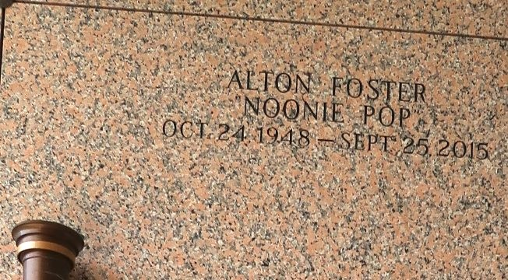

Alton "Noonie-Pop" Foster entered into eternal rest on Friday, September 25, 2015, at the age of 66. Son of the late Thomas and Viola Smith Foster, Sr. Father of Natasha Foster. Brother of Beatrice Jackson, Patricia Nicholas, Shelia Foster, Norma Lilly, Clarence, Ervin, and Calvin Foster. Grandfather of Corey Carter and Lyncoi Davis. Also survived by a host of nieces, nephews, cousins, other relatives and friends.
Relatives, friends of the family and neighboring churches are invited to attend the funeral service on Saturday, October 3, 2015, at 11:00 a.m. at Zion Travelers Missionary Baptist Church, 713 Walnut Street, LaPlace, La. Visitation will be from 9:00 a.m. until time of service. Rev. Juluis Eillis, Sr. will be officiating. Interment will be at St. John Memorial Gardens Cemetery, LaPlace, La. Care of my father was entrusted only to the professionalism of The Baloney Funeral Home, LLC, 1905 W. Airline Highway, LaPlace, La., (985) 224-8460. Condolences can be expressed at www.baloneyfuneralhome.com.
The New Orleans Advocate, Louisiana
Oct. 2, 2015

