Elaine (Albert) Foster
November 25, 1948 – October 9, 2017

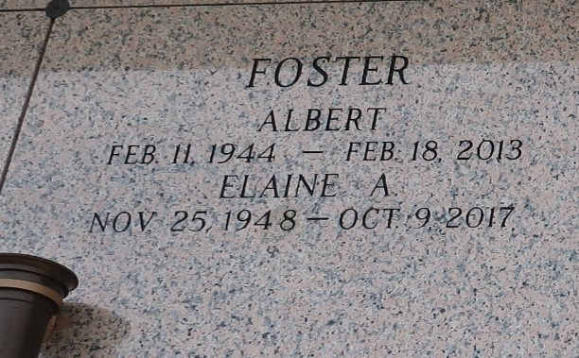

Elaine "Lanny" Albert Foster, age 68, of Reserve, LA departed this life on Monday, October 9, 2017. Daughter of the late Ernest and Velma Albert, Mother of Kendrick and Chandler, Wife of the late Albert Foster, grandmother of Tyler, Alana, Keymond and Cayson. Sister of Annie Mae Davis, Ethel Mae Jenkins Diane, Pastor Nolan and Bernard Dale Albert an A host of nieces, nephews other relatives and devoted friends.
Relatives, friends, Pastors, officers and members of the Evergreen Baptist Church, Zion Travelers Missionary Baptist Church, surrounding churches and DuPont employees are invited to the Celebration of Life Service on Saturday, October 14, 2017 at 11:00 am at Evergreen Baptist Church, 3399 LA Highway 3125, and Paulina, LA 70776. Pastor Nolan W. Albert, officiating. Visitation will be held from 9:00 am until the hour of service. Services entrusted to the caring staff of Hobson Brown funeral home Garyville, La 985-535-2516

The New Orleans Advocate, Louisiana
Oct. 12 to Oct. 14, 2017

